**1. INTRODUCTION**

In the modern workplace, effective employee management is essential for ensuring organizational productivity, accountability, and communication. Traditional methods of tracking attendance, assigning tasks, and managing internal communication are often time-consuming, error-prone, and inefficient, especially in organizations with a large workforce. To address these challenges, the “JK Office Suite” project has been developed as a comprehensive and integrated web-based platform that simplifies workforce operations for both employees (staff) and managers.

The JK Office Suite primarily aims to digitalize core human resource functionalities such as staff registration, QR code-based attendance marking, task assignment and submission, leave tracking, performance reviews, and internal messaging. One of the standout features of the system is the use of dynamically generated QR codes for each registered employee, enabling secure and accurate attendance marking via scanning or uploading QR images. This not only reduces fraudulent attendance reporting but also automates the time-in and time-out logging process.

This system is designed using the Django web framework for the backend and HTML/CSS with Bootstrap for the frontend. The database (initially SQLite) stores staff records, attendance logs, task assignments, performance reviews, and messages. The use of libraries like qrcode for QR generation and jsQR or OpenCV for decoding adds a layer of technological innovation to the traditional employee management systems.

Managers can log in to their dashboard to register new staff, assign and monitor tasks, approve or reject leave requests, review employee performance, and view submitted tasks. Staff, on the other hand, can scan their QR codes to mark attendance, view their assigned tasks, submit deliverables, and send messages to their managers. The platform is designed with role-based access, ensuring that managers and staff interact with the system in ways appropriate to their roles.

The JK Office Suite is intended to be scalable and adaptable for small to medium-sized businesses. It emphasizes efficiency, security, usability, and data integrity, offering organizations a modern and paperless alternative to manual processes. This report provides a detailed exploration of the system's design, implementation, and evaluation, and discusses how it contributes to smarter office management in the digital age.

In conclusion, JK Office Suite brings a modern, efficient, and scalable solution to the conventional HR management process. It not only automates manual administrative tasks but also fosters a more transparent and productive work environment. As businesses continue to embrace digital transformation, solutions like this play a crucial role in bridging technological gaps in everyday office operations.

**COMPANY PROFILE**



JK Innovative Private Limited is incorporated in the Year 2014 under Ministry of Corporate Affairs, Government of India. JK Innovative Pvt. Ltd. (India) based ISO 9001:2015 [ IT & CAD Services based Company] in Amravati which brings a wealth of experience and expertise in the fields of Technical Training, Developing Professional Software & Projects, Website development & SEO, Mobile Application development, Internship & Placement Assistance. Our development team works with clients to determine the scope and nature of the work to be performed from inception through completion and beyond. Company Started working in Cherished Memories of JAYESH KABRA (JK) who always inspired us to be Goal Achievers with Loyalty, Integrity ‒ exhibit honesty and most Important with Innovative Methods, so we registered the Brand Name with JK Innovative Private Limited. We are a professionally recognized software development company having huge experience in developing custom software development and application development best match to your need and requirements. We have expertise in working with a variety of customers from companies to individuals. Our successful assignments with client companies have established our reputation as superior providers of IT solutions.

In this ever-changing environment, keeping a competitive edge means being able to anticipate and respond quickly to changing business conditions. JK Innovative is a global software development company providing IT solutions to enterprises worldwide.

👉Mission:

"To establish this company as a premier software solutions company, dedicated to innovate yet pragmatic offerings, which provide sustained competitive advantage to its global customers?

👉Values and Beliefs:

Ever since the inception, we have operated in accordance with a set of core values and beliefs, which are critical to our continued success as a company, and as individuals.

👉Our Customer Centric:

In a true "partner" spirit work with customers to diagnose core business issues, define and deliver innovative solutions, and then support the customer to provide them with sustained competitive advantage. Always strive to exceed the customer expectation, Respect individuality, while recognizing that above all, nothing, nothing wins like Teamwork.

👉 Environment:

For our team - hire the best and treat them well, provide a first-class working environment and offer the opportunity to participate in the ownership and economic success of the company

### **Software Requirements**

|  |  |
| --- | --- |
| **Component** | **Description** |
| **Operating System** | Windows 10/11, Ubuntu 20.04+, macOS (Developer’s system) |
| **Backend Framework** | Django (Python 3.9+) |
| **Frontend Technologies** | HTML5, CSS3, JavaScript, Bootstrap, jQuery |
| **Database** | PostgreSQL or MySQL (Recommended: PostgreSQL for better scalability) |
| **Application Server** | Apache |
| **IDE/Editor** | PyCharm |
| **Browser** | Chrome, Firefox, Edge (Latest versions) |
| **Version Control System** | Git, GitHub/GitLab |
| **Dependencies & Libraries** | Django REST Framework, djangorestframework-simplejwt, Pillow, QR Code lib |
| **Email Service** | SMTP-based (Gmail SMTP or SendGrid API) |
| **Testing Tools** | Postman, PyTest, Django Test Framework |

**Hardware Requirements**

|  |  |  |
| --- | --- | --- |
| **Component** | **Minimum Specification** | **Recommended Specification** |
| **Processor (CPU)** | Intel i3 or AMD equivalent | Intel i5/i7 or AMD Ryzen 5/7 |
| **RAM** | 4 GB | 8–16 GB |
| **Storage** | 128 GB HDD or SSD | 256 GB SSD or higher |
| **Display** | 13” Monitor (1366×768) | 15” Monitor (1920×1080 Full HD) |
| **Network** | Internet connection (for updates & APIs) | High-speed broadband (for deployment) |
| **Peripherals** | Keyboard, Mouse | Keyboard, Mouse, Printer (optional) |

## 2. LANGUAGE USED

The JK Office Suite is developed using a modern, full-stack web development approach. The following programming and scripting languages were used throughout the project:

#### ****1. Python****

* Used for backend development via the Django web framework.
* Facilitates server-side logic, API development, database interactions, and authentication workflows.
* Known for readability, rapid development, and scalability.

#### ****2. HTML (HyperText Markup Language)****

* Used to structure the web pages and content displayed to users.
* Acts as the foundation for all frontend interface development.

#### ****3. CSS (Cascading Style Sheets)****

* Used to style and format the user interface elements.
* Ensures the web app is visually responsive and user-friendly.

#### ****4. JavaScript****

* Enables dynamic client-side behavior.
* Used for interactive elements like dropdowns, modals, form validation, and real-time updates.

#### ****5. SQL (Structured Query Language)****

* Used implicitly through Django ORM (Object Relational Mapping) to interact with the PostgreSQL or MySQL database.
* Handles data queries, updates, insertions, and schema management.

#### ****6. JSON (JavaScript Object Notation)****

* Used for data exchange between frontend and backend, particularly in RESTful API responses.
* Lightweight and easy to parse.

#### ****7. Shell/Bash Scripting (optional)****

* Used for server deployment, environment setup, and automation scripts.

## 3. SYSTEM ANALYSIS

## ****3.1 Software Development Life Cycle (SDLC)****

The **Software Development Life Cycle (SDLC)** is a structured process followed during software development that outlines each phase involved in building and maintaining high-quality software systems. For the **JK Office Suite** project, the **Agile SDLC Model** was adopted due to its flexibility, fast iterations, and client feedback integration at every step.

### **Why Agile?**

* Allows incremental and iterative development.
* Supports continuous feedback from stakeholders.
* Enables faster delivery of functional modules.
* Ideal for dynamic projects where requirements may evolve over time.

### **Phases in the SDLC for JK Office Suite**

### **1. Requirement Analysis**

* **Goal:** Understand the client’s operational challenges and expectations.
* **Activities:**
  + Conducted interviews with Directors, HRs, Managers, and Staff.
  + Collected pain points regarding manual attendance, fragmented task tracking, and leave approval delays.
  + Defined user roles and the specific needs of each.

### **2. System Design**

* **Goal:** Translate requirements into a blueprint for development.
* **Activities:**
  + Designed high-level architecture (MVC structure).
  + Created wireframes for user dashboards.
  + Developed Data Flow Diagrams (DFDs), Entity Relationship Diagrams (ERDs), and use case models.
  + Planned the database schema with normalized tables.

### **3. Implementation (Coding)**

* **Goal:** Convert design documents into functional modules using code.
* **Technologies Used:**
  + **Backend:** Python with Django Framework
  + **Frontend:** HTML5, CSS3, JavaScript, Bootstrap
  + **Database:** PostgreSQL
* **Activities:**
  + Developed features in sprints (company registration, QR attendance, task modules, etc.).
  + Integrated role-based access control.
  + Applied best practices for code reuse and modularity.

### **4. Testing**

* **Goal:** Ensure the system works as expected, without bugs or vulnerabilities.
* **Types of Testing Used:**
  + **Unit Testing:** Each module was tested independently (e.g., QR scan, leave form).
  + **Integration Testing:** Verified how modules work together (e.g., login → dashboard → leave request).
  + **System Testing:** Validated the entire system's workflow.
  + **User Acceptance Testing (UAT):** Conducted sessions with real users from different roles to collect feedback and fine-tune usability.

### **5. Deployment**

* **Goal:** Make the software live and available to users.
* **Deployment Tools & Environment:**
  + Deployed using **Gunicorn** (WSGI) and **Nginx** as a reverse proxy on a **Linux server**.
  + Ensured database security, backup automation, and SSL integration.
  + Set environment variables securely for production.

### **6. Maintenance**

* **Goal:** Keep the system up-to-date and running smoothly after deployment.
* **Activities:**
  + Monitoring performance and fixing bugs.
  + Adding new features (e.g., recruitment module, salary slips).
  + Providing user support and documentation updates.
  + Future enhancements like mobile app support, chatbot, and AI analytics are planned.

### **Key Benefits of This SDLC Approach**

* Ensures a **structured workflow** and reduces risk of miscommunication.
* Provides **early delivery** of modules for client review.
* Enables **faster iterations** and response to change.
* Guarantees **quality assurance** through continuous testing.

### **3.2 Functional Requirements**

Functional requirements define the operations and services the system must perform to meet the needs of its users.

#### ****Director Functionalities:****

* Register and manage HRs and Managers.
* Monitor total employees, attendance, task progress, and reports from the dashboard.
* View consolidated leave requests and approve or reject them.

#### ****HR Functionalities:****

* Add and manage Staff members.
* Assign departments and salary details.
* Manage recruitment postings and track applicants.
* View leave records, attendance, and staff performance analytics.

#### ****Manager Functionalities:****

* Assign tasks to staff members.
* View task submissions and evaluate progress.
* Review and approve/reject staff leave applications.
* Monitor staff attendance and send internal messages.

#### ****Staff Functionalities:****

* Mark daily attendance using QR code system.
* View and complete assigned tasks, with the ability to upload screenshots in case of issues.
* Submit leave applications and view current status.
* Restricted logout until assigned tasks are submitted successfully.

### **3.3 Non-Functional Requirements**

Non-functional requirements define the quality attributes, performance metrics, and system behavior under constraints.

#### ****Performance:****

* The system must support multiple concurrent users without performance degradation.
* Fast page loads and efficient server responses are expected under normal and peak load conditions.

#### ****Scalability:****

* The system is designed with scalability in mind so that additional features and user roles can be added without major architectural changes.
* Horizontal scaling is possible by deploying instances across servers.

#### ****Security:****

* User authentication uses Django’s built-in secure auth system and JWT for token-based sessions.
* Passwords are encrypted using industry-standard hashing algorithms.
* All user data and access rights are controlled via **Role-Based Access Control (RBAC)**.

#### ****Usability:****

* Responsive and intuitive UI accessible across devices (desktop, tablet, mobile).
* Designed with clean layouts and straightforward navigation to reduce user training.

#### ****Availability:****

* Designed for high availability with a target uptime of 99.9%.
* Regular backups and monitoring tools are integrated to ensure system availability.

#### ****Maintainability:****

* Code is written in a modular and component-based structure for easier debugging and enhancement.
* Clear documentation and use of Git version control allow seamless collaboration among developers.

#### ****Portability:****

* The system can be deployed on any OS or server that supports **Python 3.x** and **PostgreSQL/MySQL**.
* Containerized deployment (e.g., Docker) is supported for portability across environments (Dev/Test/Prod).

This detailed system analysis lays the foundation for a robust, scalable, and user-friendly office management solution aligned with modern enterprise requirements.

## 4. Data Flow Diagram

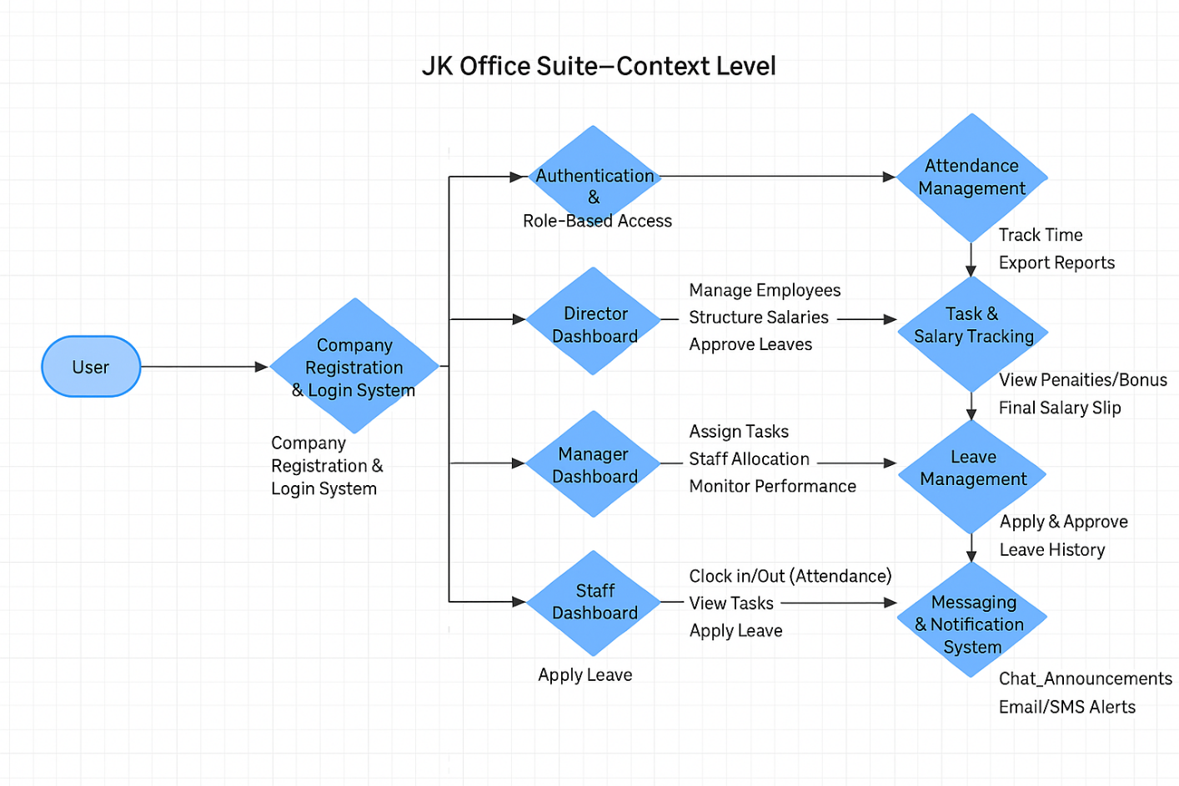

## UML Diagrams

## 

## 1.1 Director

## 

## 1.2 HR

## 

## 1.3 Manager

## 

## 1.4 Staff

## 6. PROPOSED FUNCTIONALITY

## (Detailed Working of the Project)

**Project Name:** JK Office Suite – Enterprise Office Management Portal

### Overview:

The JK Office Suite is a role-based, modular web application developed using Django, aimed at automating and managing core office functions such as registration, attendance, task management, leave tracking, salary generation, recruitment, and inter-role communication. Each role (Director, HR, Manager, Staff) has its own dedicated interface and dashboard.

The suite offers an all-in-one enterprise-grade solution designed to streamline organizational operations with precision, role clarity, and accountability.

### 6.1 Company Registration & Unique Code Generation

* The process begins with the registration of a company by the Director.
* On successful registration, a **unique company code** is generated and emailed to the Director.
* This code is used to register HRs, Managers, and Staff under the same company.
* Upon registration, each user receives auto-generated login credentials via email.

### 6.2 Role-Based Authentication System

* Each user logs in securely using their credentials.
* Users are redirected to their role-specific dashboards:
  + **Director**: Full system control
  + **HR**: Staff management and recruitment
  + **Manager**: Task delegation and leave approvals
  + **Staff**: Attendance, task submission, and communication

### 6.3 Director Module Functionality

* Register HRs, Managers, and Staff using the unique company code.
* Full control over company settings (name, email, phone, address).
* Monitor:
  + Company-wide employee hierarchy
  + Salary structure
  + Attendance reports
  + Leave requests
  + System notifications
* Access analytics and reports on performance, attendance, and task status

### 6.4 HR Module Functionality

* HR receives credentials upon registration.
* Functionalities:
  + Register and manage staff and managers.
  + Allocate departments and structure salaries.
  + Generate payslips/receipts in PDF format.
  + Recruitment panel: post jobs, manage applicants.
  + Review employee performance and manage records.
  + Generate staff-level reports.

### 6.5 Manager Module Functionality

* Registered by Director or HR.
* Dashboard provides:
  + Task Assignment panel with list of staff.
  + Task List with status updates and timestamps.
  + Leave Request management (approve/reject).
  + Staff registration and profile updates.
  + Messaging system for internal communication.
  + Profile settings and secure logout.

### 6.6 Staff Module Functionality

* Staff registered by Director, HR, or Manager.
* Credentials received via email.
* Functionalities:
  + Clock-in/out using **QR Code Attendance System**.
  + Submit tasks only after attendance marking.
  + Upload screenshots and remarks for task completion.
  + Apply for leave and track approval status.
  + Receive notifications and internal messages.
  + View and edit personal profile.
  + Logout restricted until task submission is complete.

### 6.7 Admin Panel

* Accessible via Admin Login.
* Can manage:
  + All user records (Director, HR, Manager, Staff)
  + Registered company details
  + System-wide database for reporting and audits

### 6.8 Attendance Management

* Attendance marked using unique QR code (scanned or uploaded).
* Secret keys encoded in QR for identity verification.
* System logs login and logout time.
* Directors and HRs can view attendance summaries.

### 6.9 Task Assignment & Error Reporting

* Tasks assigned by Managers with due dates and objectives.
* Staff must complete tasks before logging out.
* If unable, they can:
  + Upload screenshots
  + Add remarks
* Manager reviews submissions and provides feedback or resolution.

### 6.10 Leave Management System

* Staff applies for leave through dashboard.
* Approval process flows from **Manager → HR → Director**.
* Status is updated in real time.
* History is stored for future reference.

### 6.11 Messaging & Notification System

* Managers and higher roles can send direct messages.
* Staff views messages in dedicated messaging panel.
* Notifications include:
  + Task assignments
  + Leave status
  + System alerts
* Delivered via internal dashboard and optionally Email/SMS.

### 6.12 Salary and Recruitment Management (HR)

* HR manages salary inputs and structure.
* Generates payslips and receipts in PDF format.
* Recruitment module includes:
  + Job posting
  + Applicant tracking
  + Exporting data to PDF/CSV

### 6.13 PDF & Reporting Features

* Uses xhtml2pdf, reportlab, and qrcode for:
  + Generating PDFs for reports, payslips, recruitment logs.
  + Encoding secure QR data for attendance.
* Reports accessible by Director and Admin for decision-making.

**7. OUTPUT & DESIGN**

**HOMEPAGE**

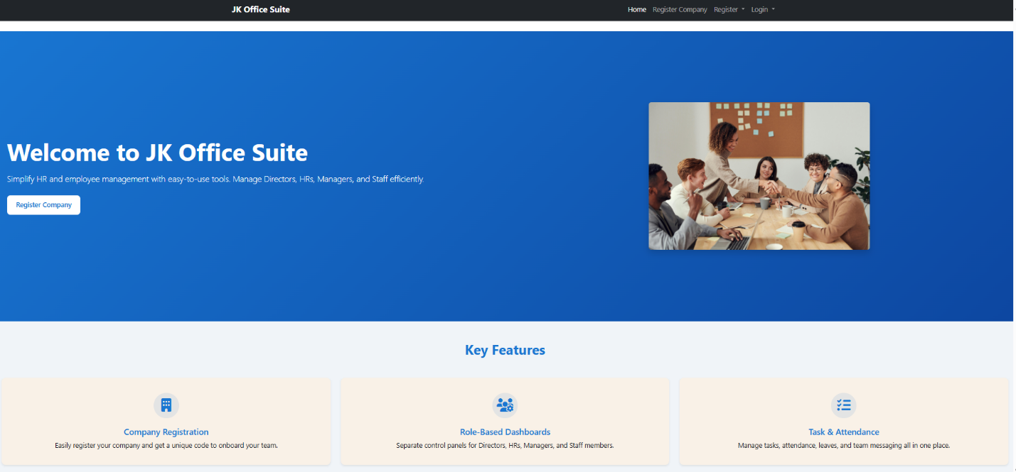

**DIRECTOR APP**

**COMPANY REGISTRATION**

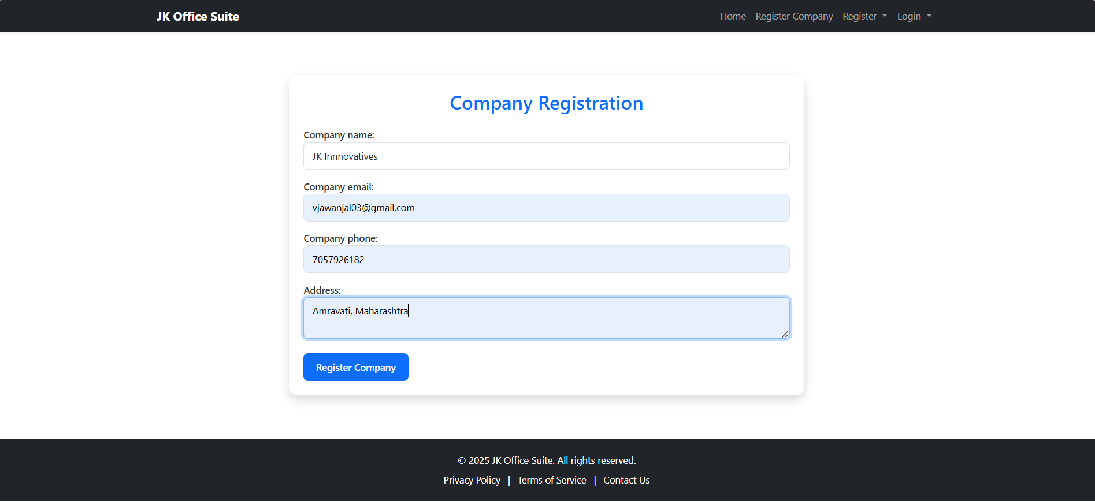

**COMPANY REGISTRATION MAIL**

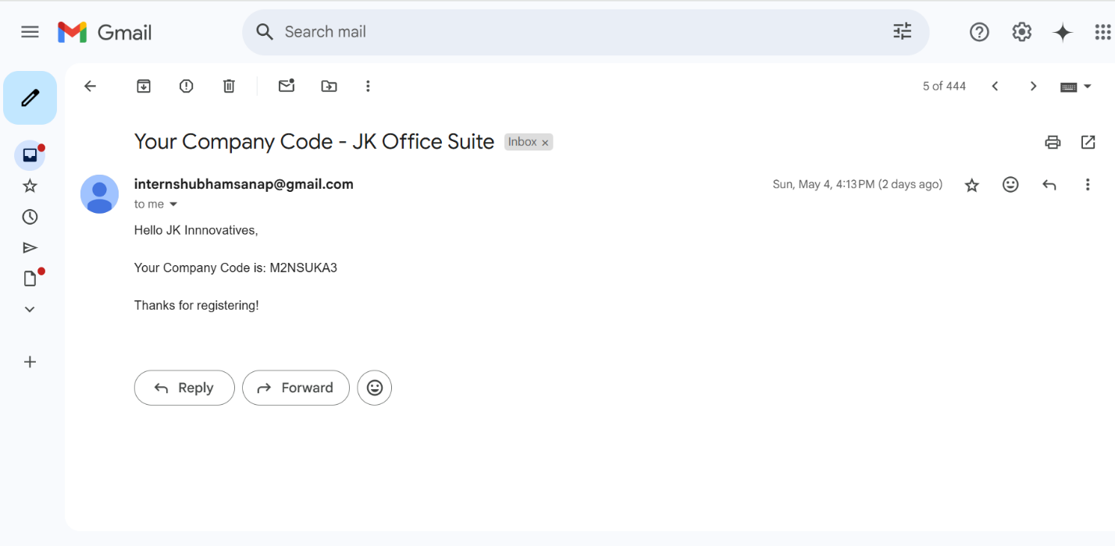

**DIRECTOR REGISTRATION**

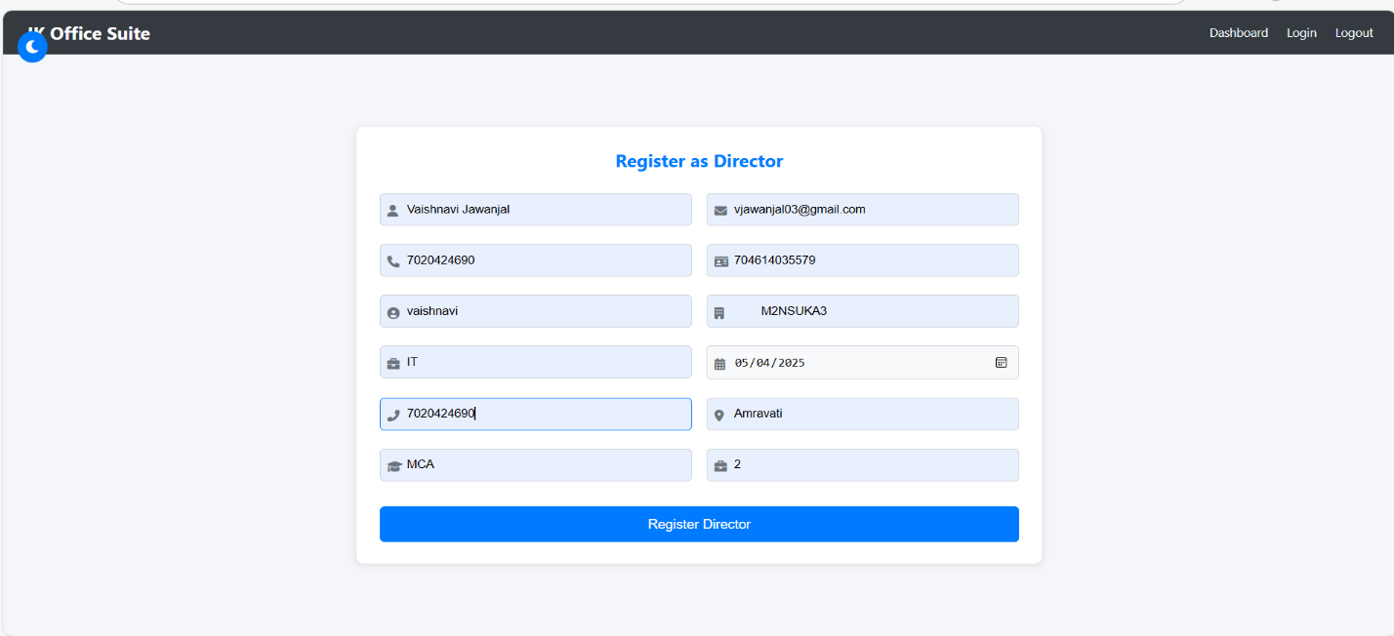

**MAIL RECEIVED BY DIRECTOR**

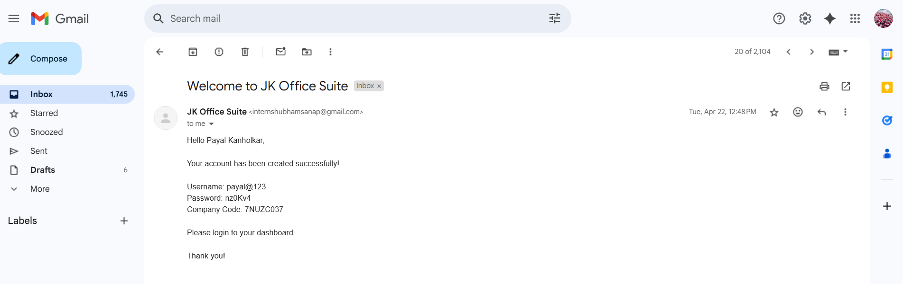

**DIRECTOR LOGIN**

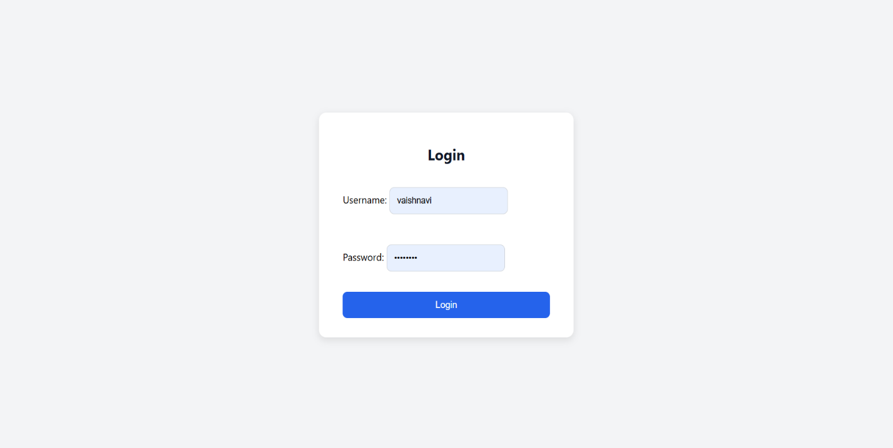

**DIRECTOR DASHBOARD**

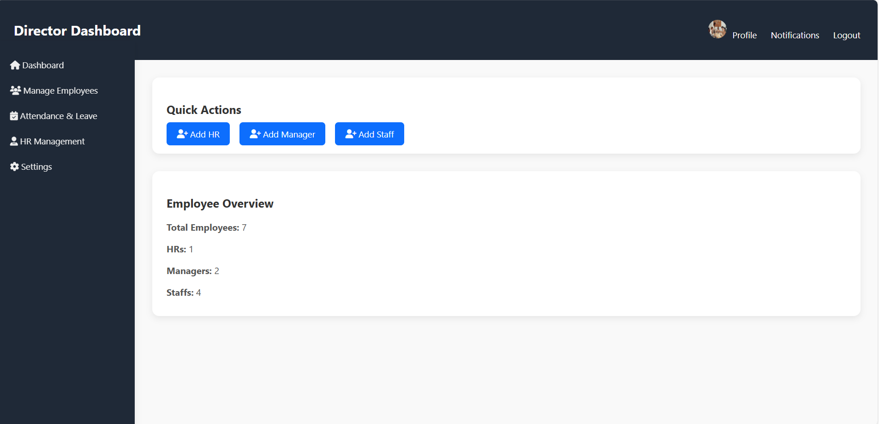

**MANAGER REGISTRATION**

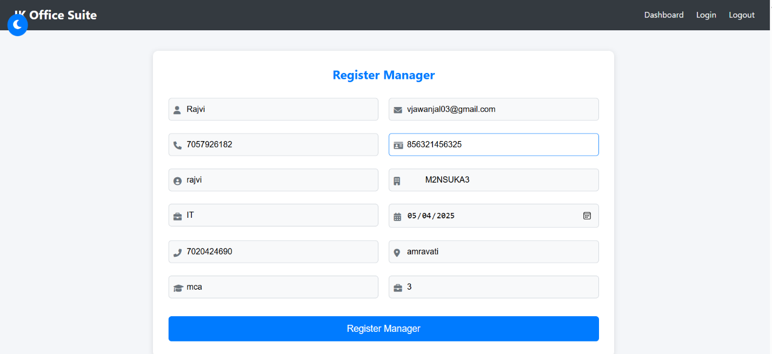

**HR REGISTRATION**

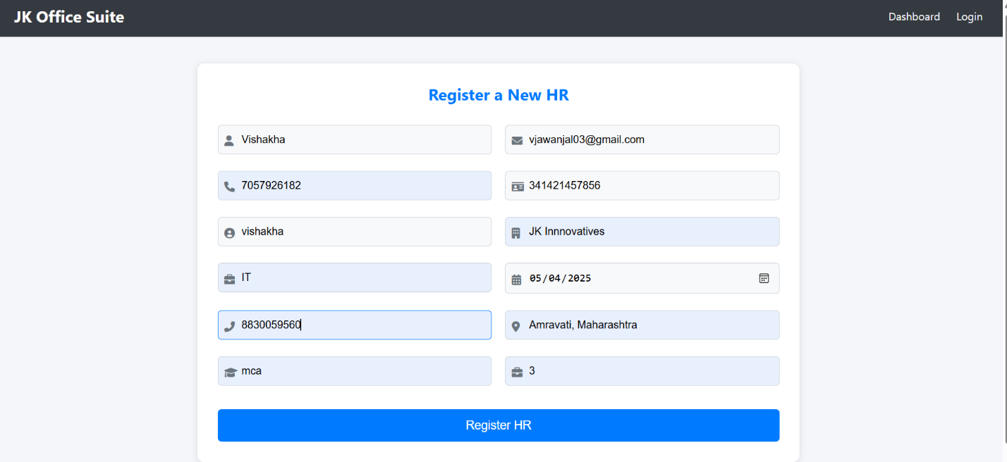

**STAFF REGISTRATION**

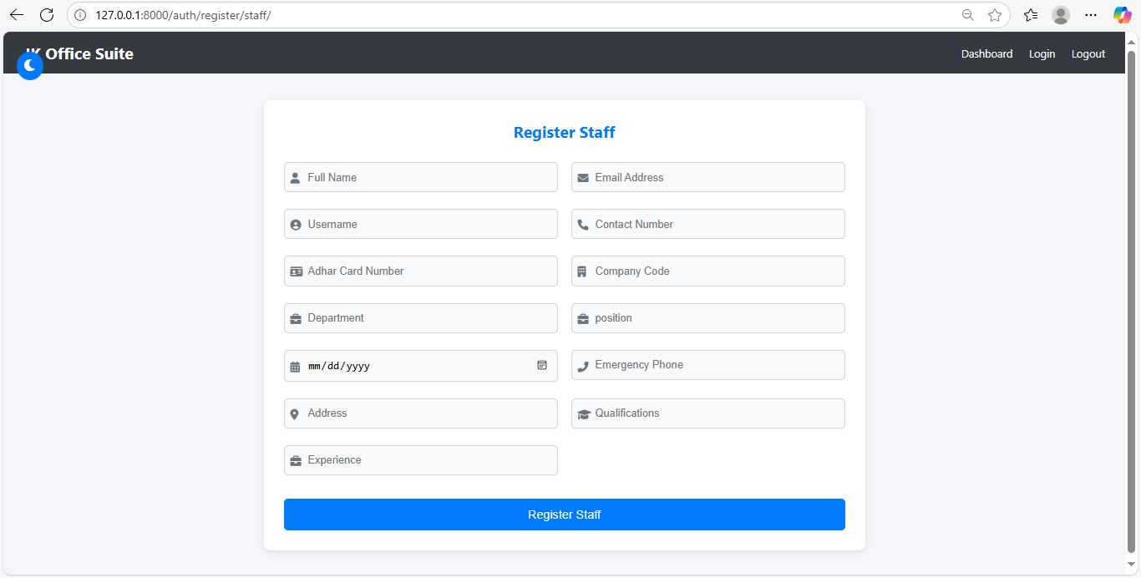

**DIRECTOR PROFILE**

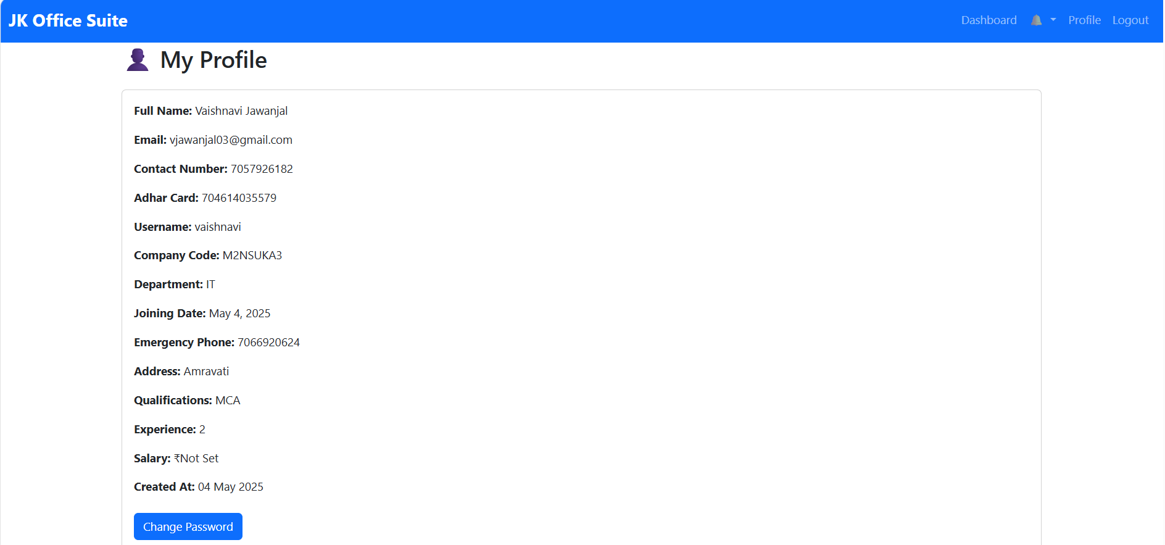

**NOTIFICATIONS**

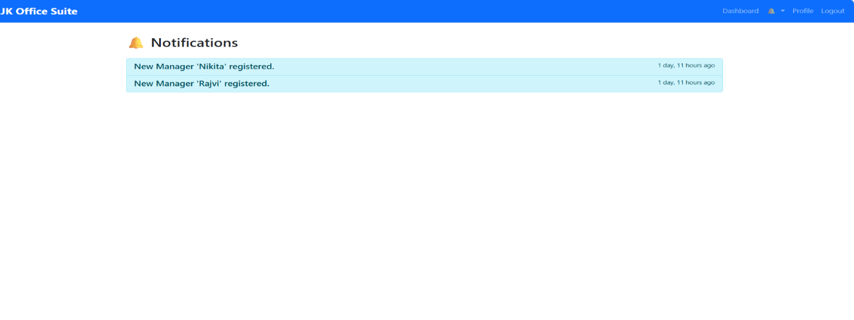

**MANAGE EMPLOYEES**

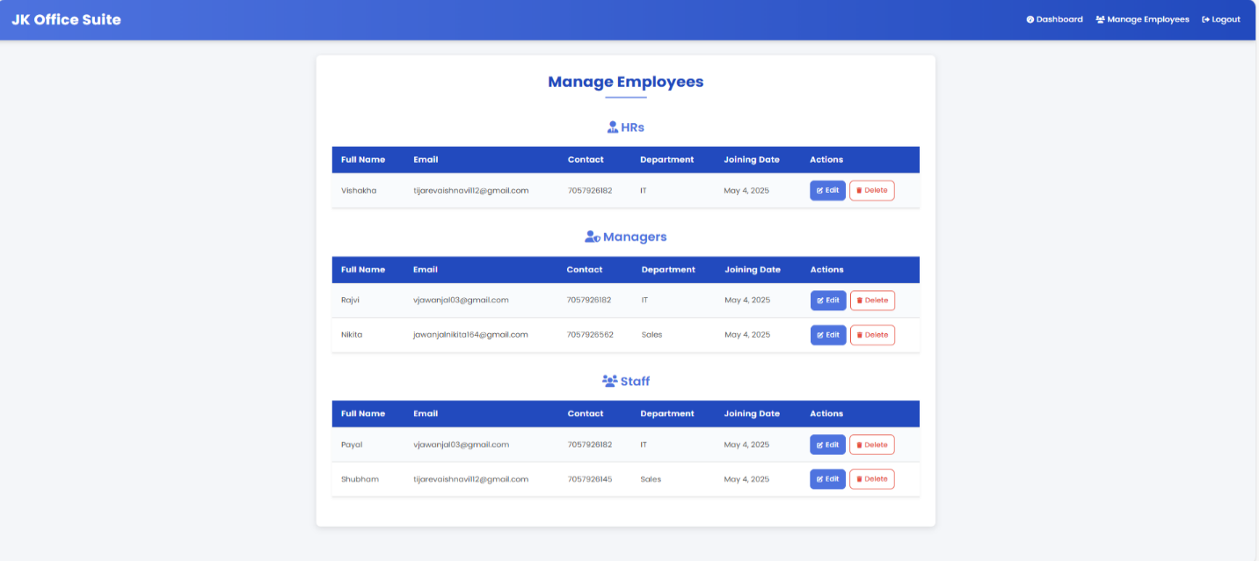

**ATTENDANCE AND LEAVE**

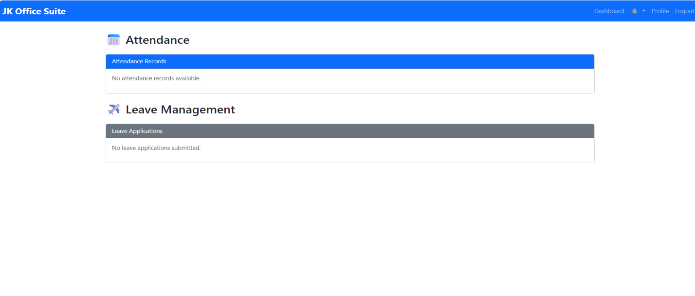

**HR MANAGEMENT**

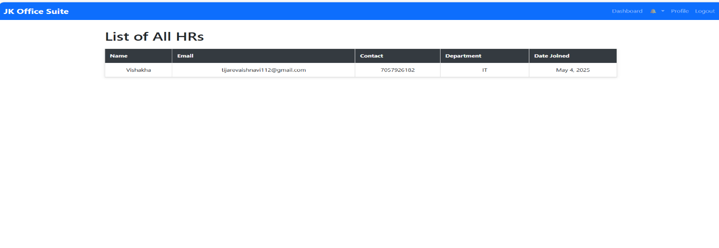

**SETTINGS**

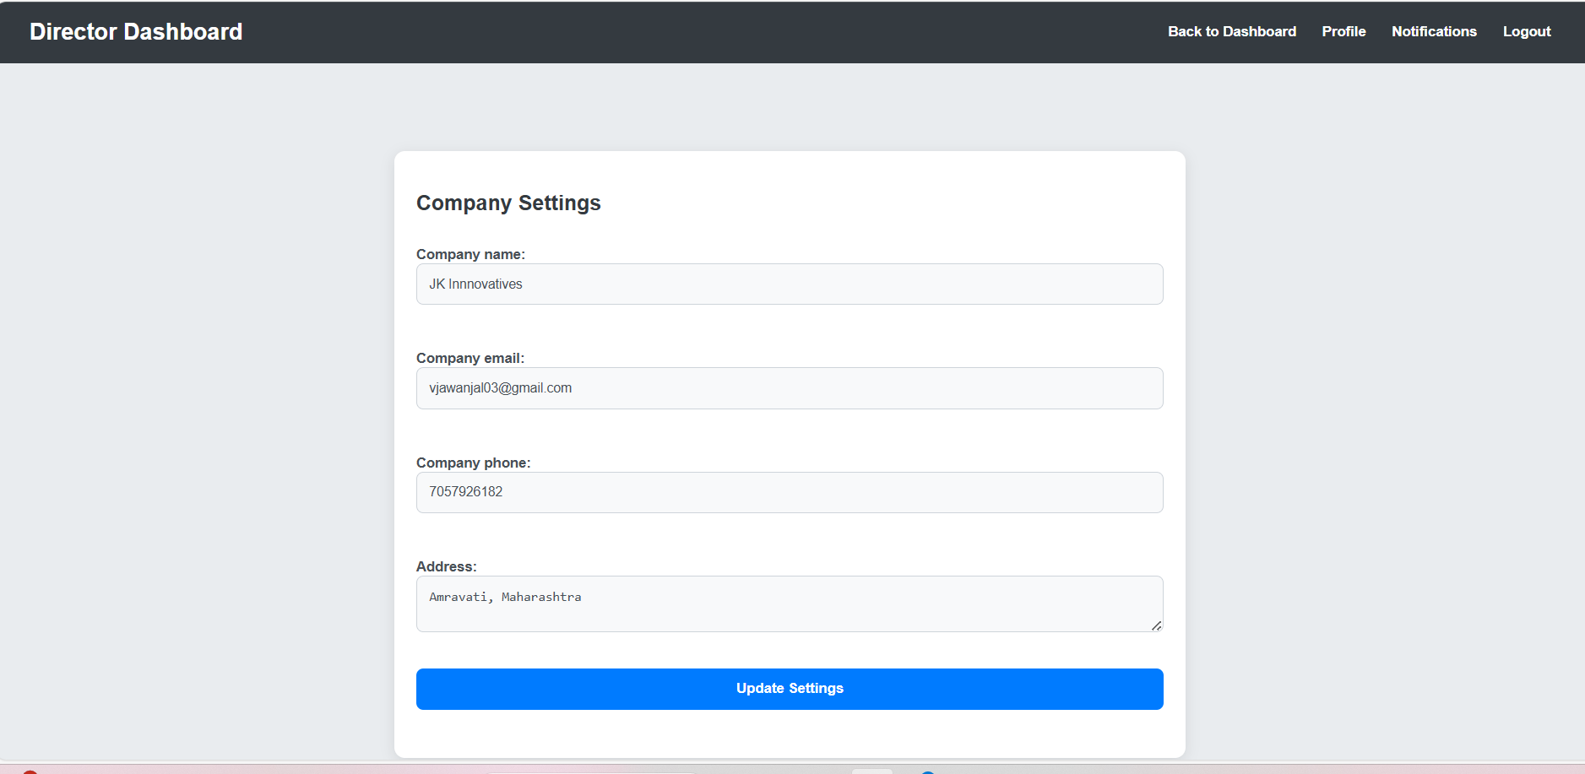

**HR APP**

**RECEIVED MAIL**

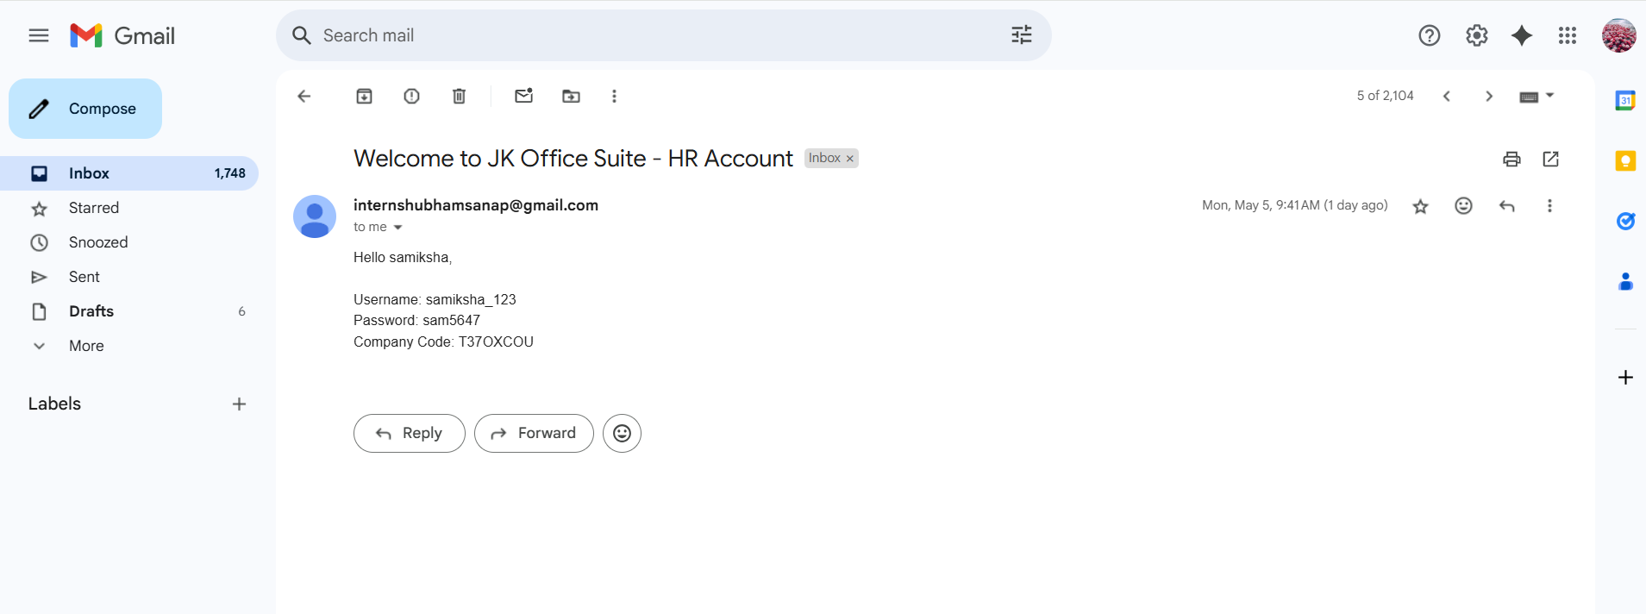

**USER LOGIN PAGE**

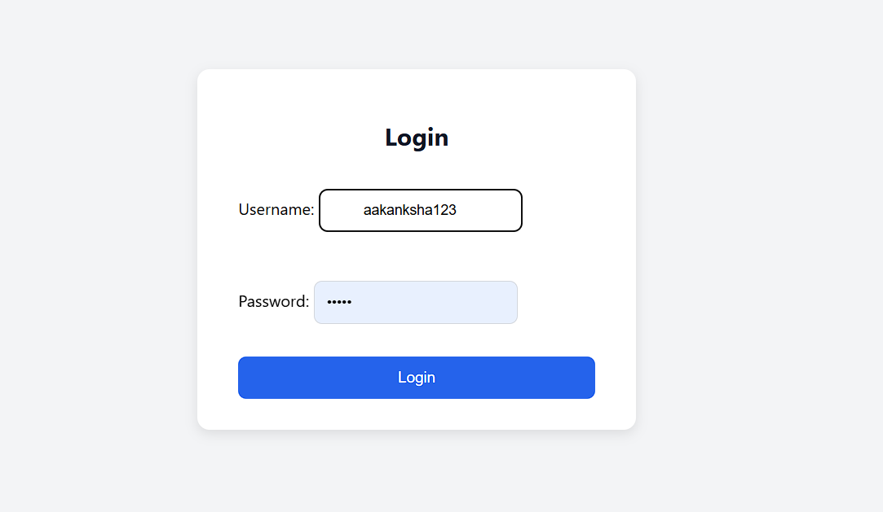

**HR DASHBOARD**

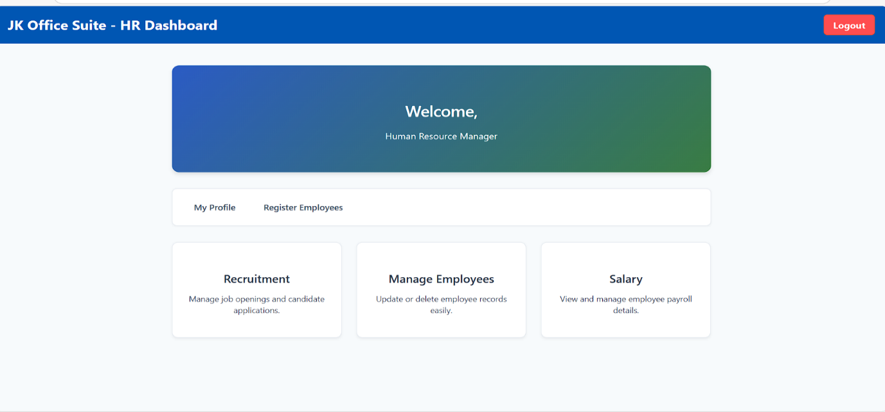

**PROFILE PAGE**

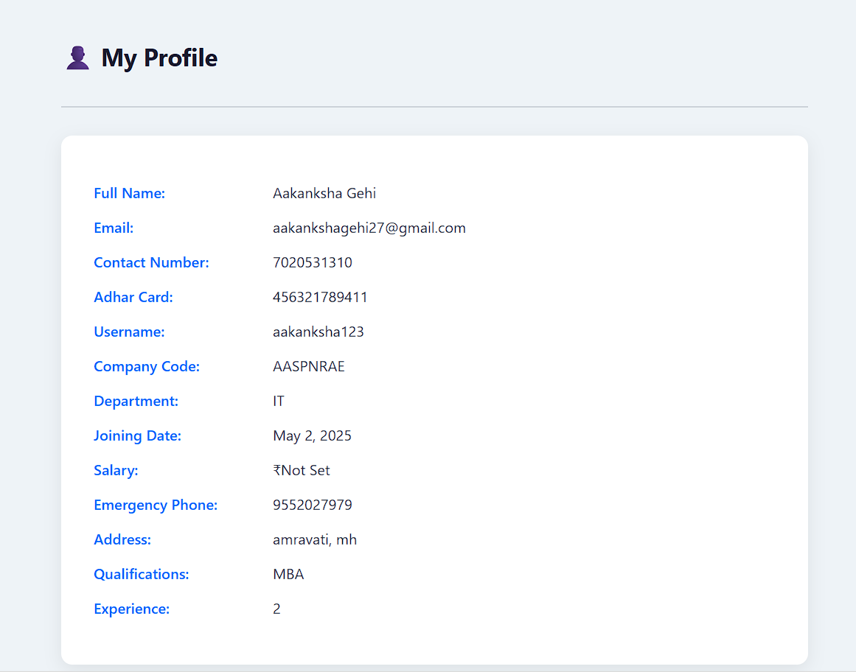

**EMPLOYEES PANEL**

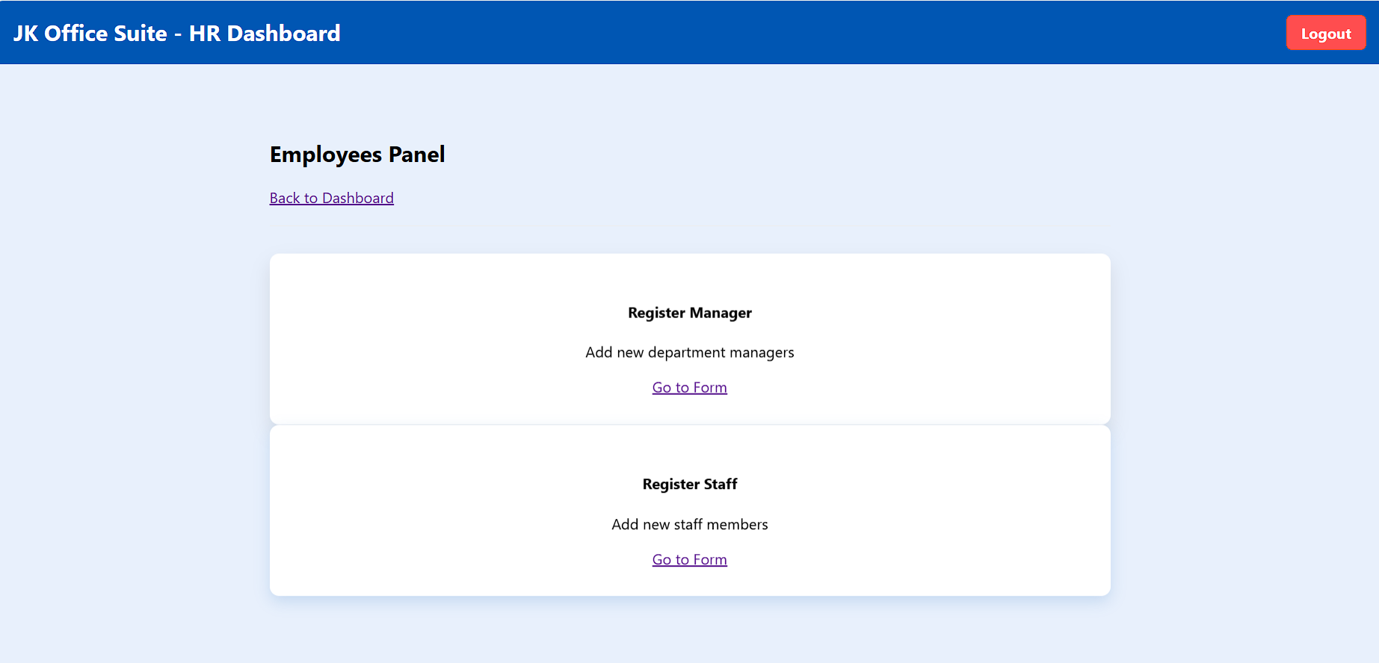

**RECRUITMENT PAGE**

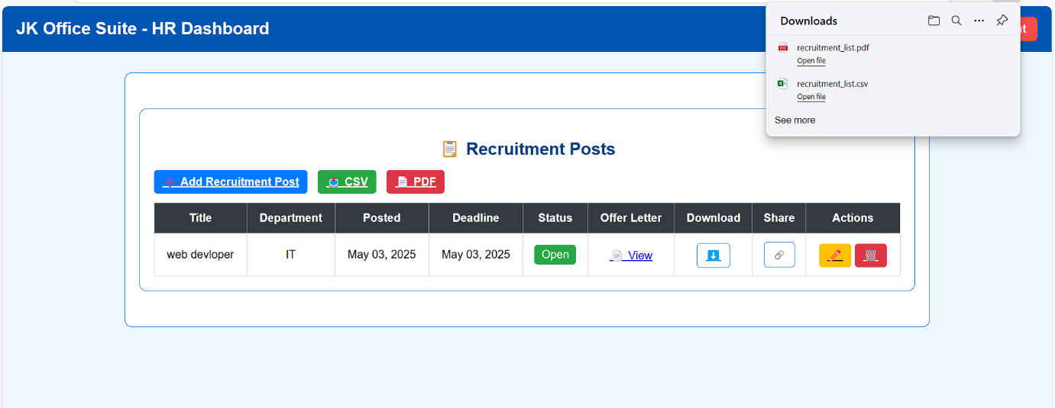

**MANAGE EMPLOYEES**

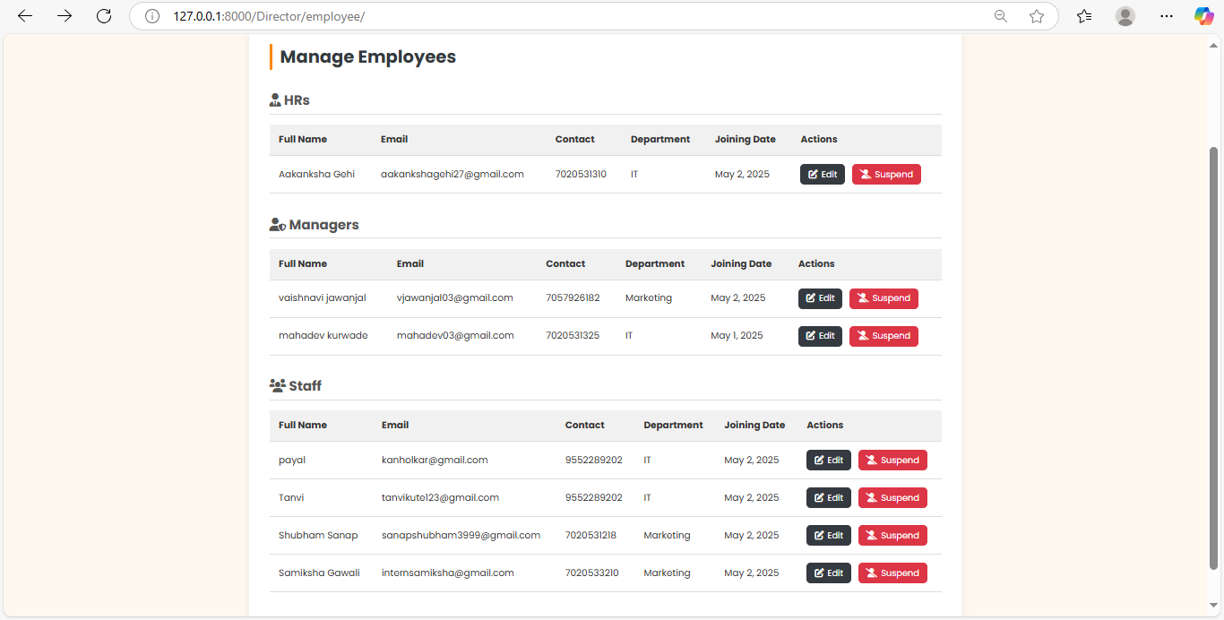

**SALARY MANAGMENT**

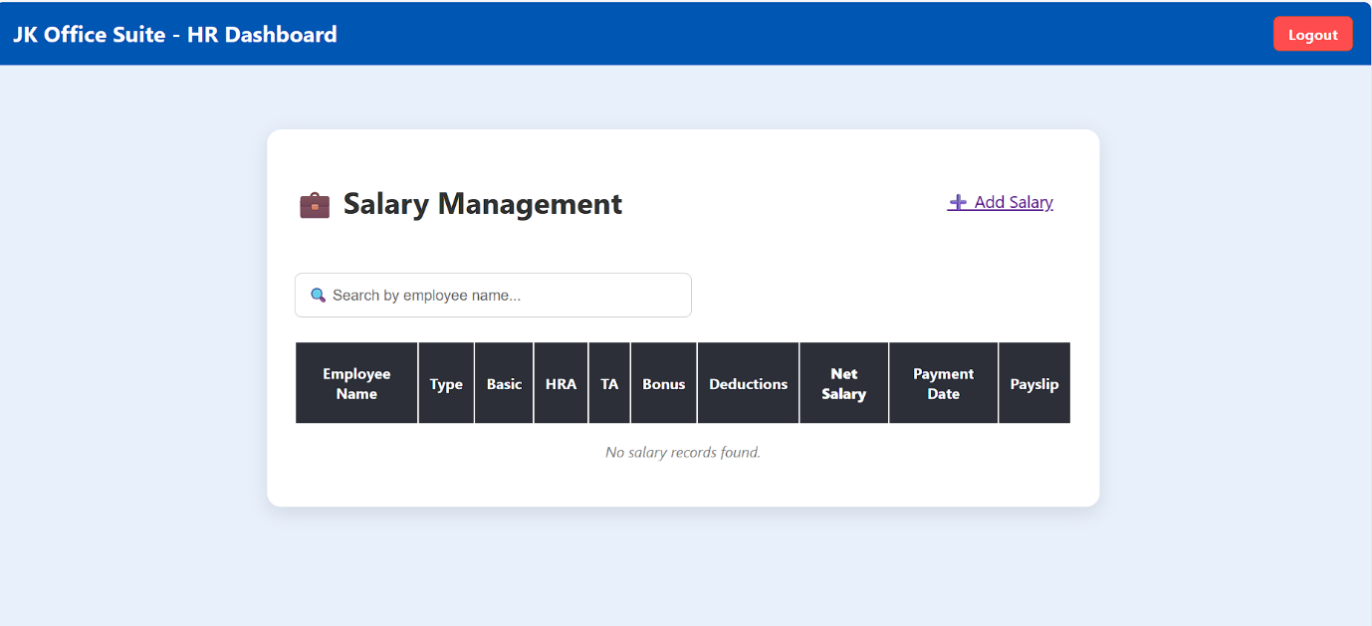

**SALARY PAGE**

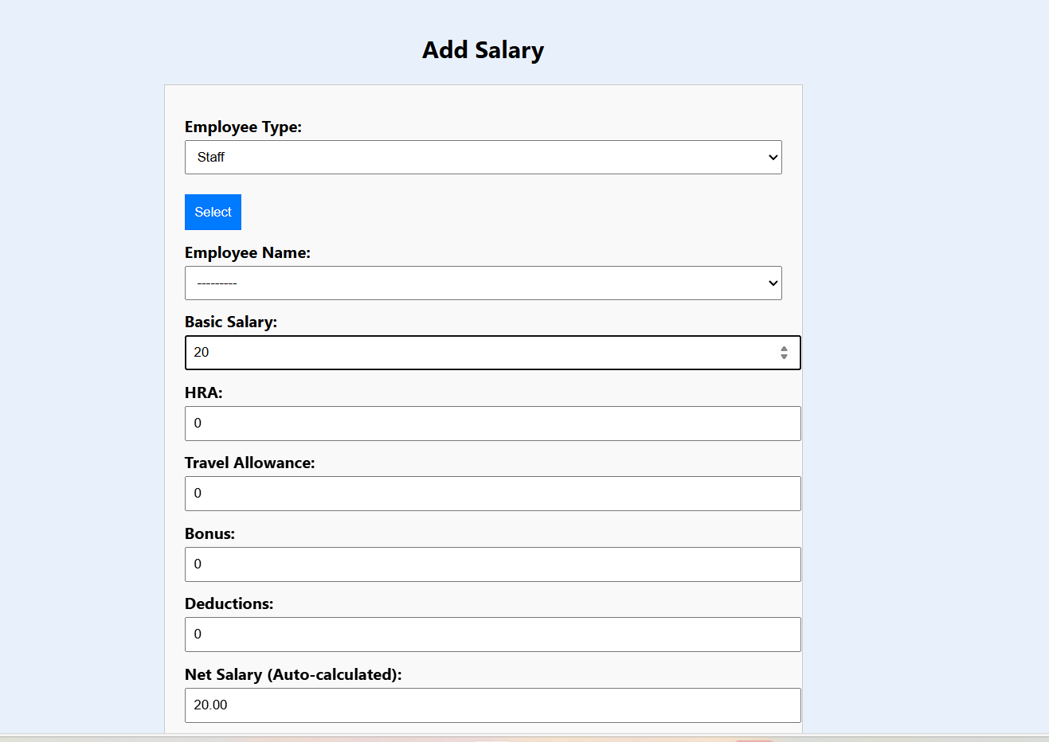

**GENERATED RECEIPT**

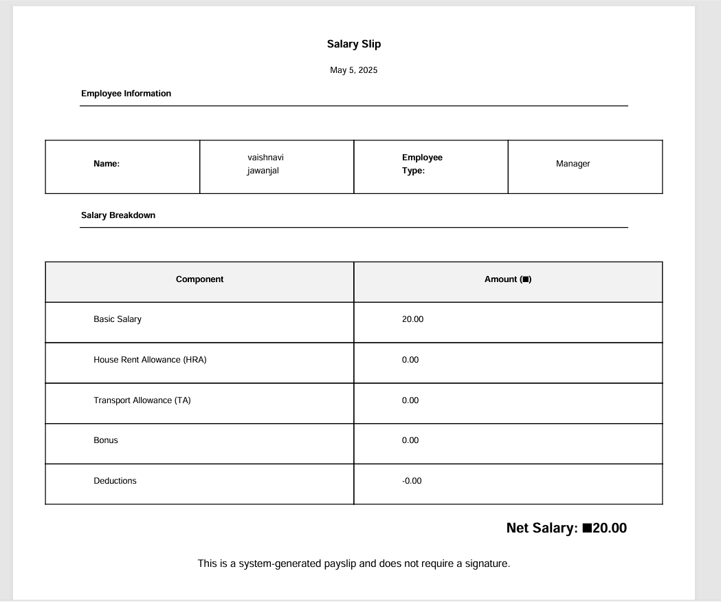

**MANAGER APP**

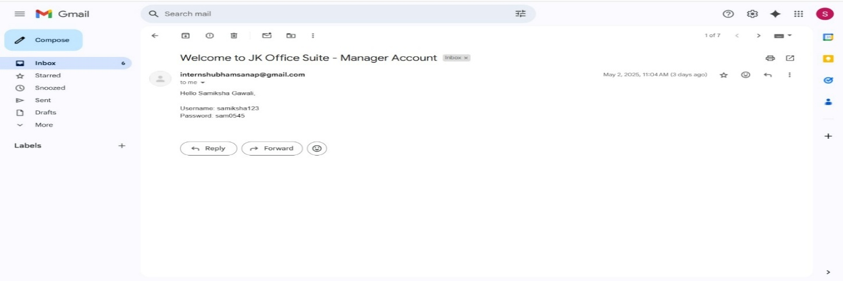**MAIL SENT AFTER MANAGER REGISTRATION**

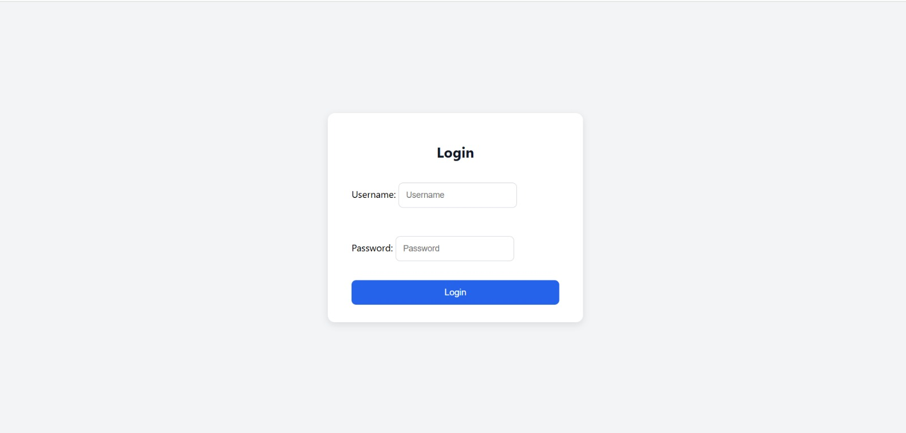**USER LOGIN PAGE**

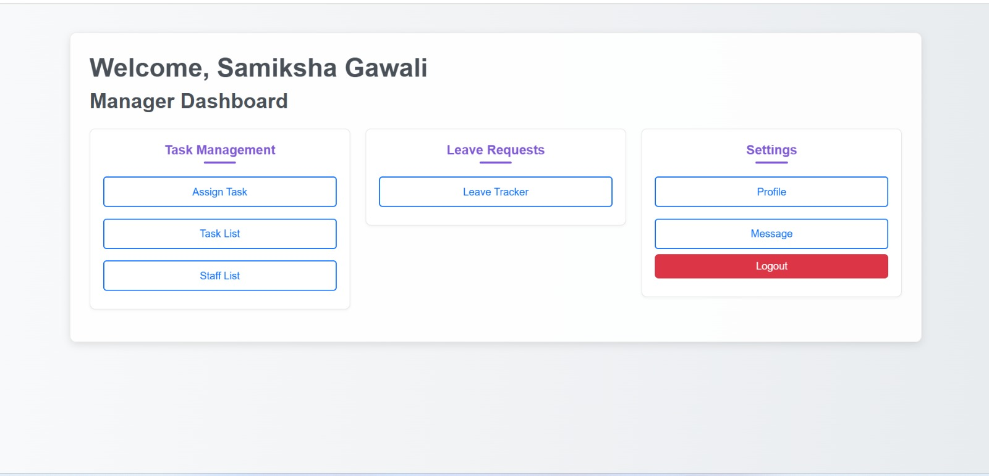**MANAGER DASHBOARD**

**ASSIGN TASK PAGE-I**

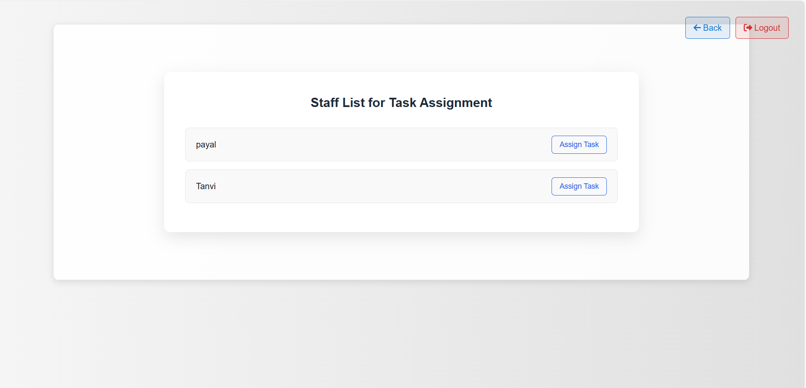

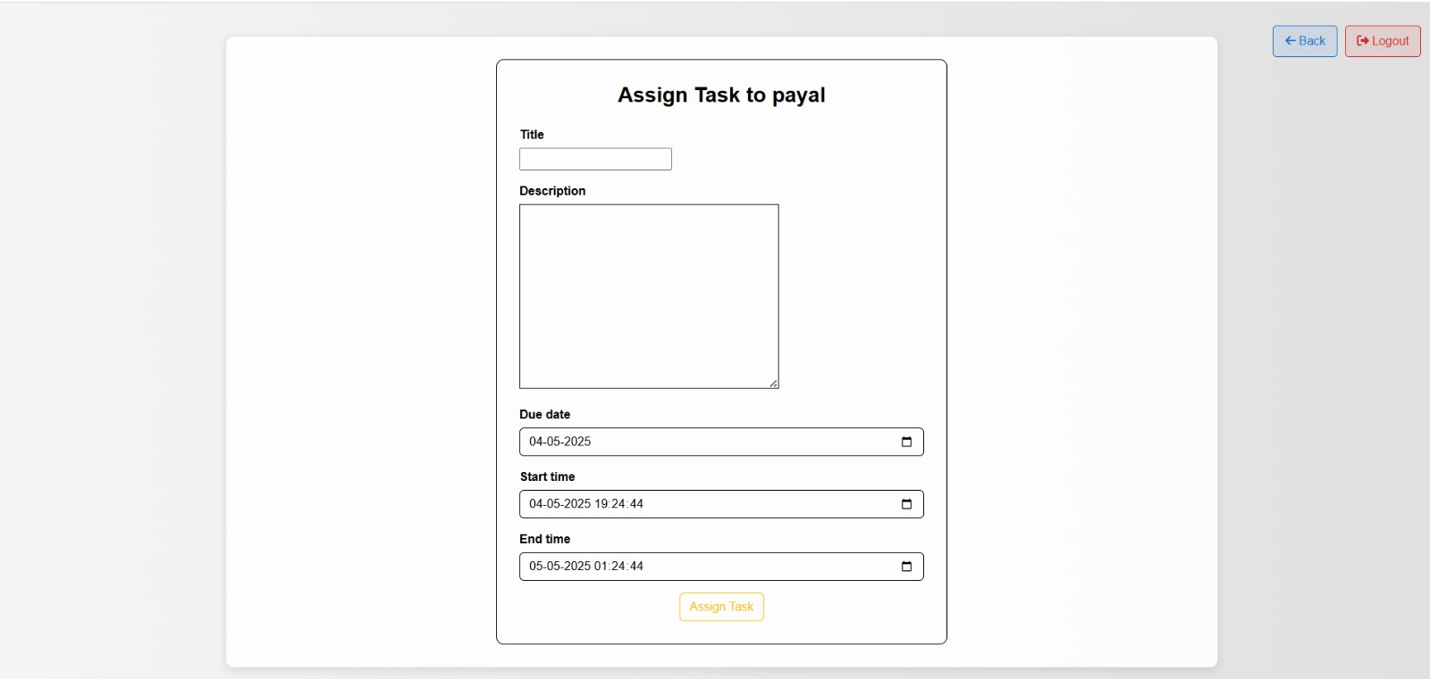**ASSIGN TASK PAGE-II**

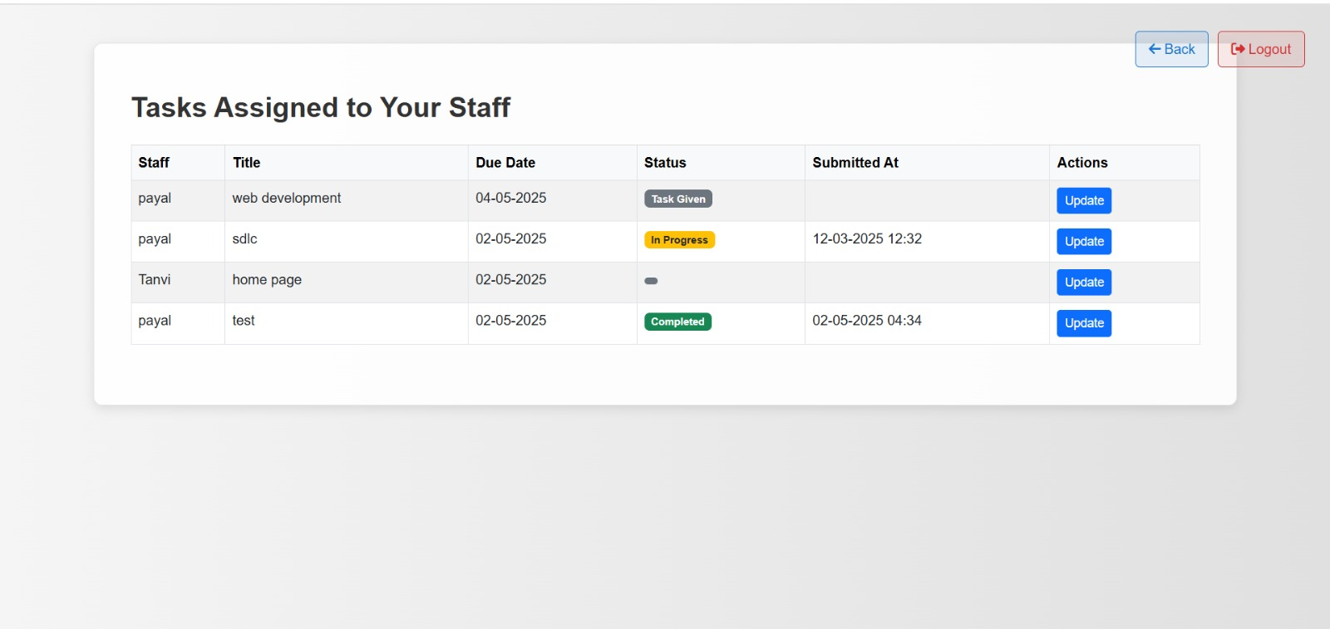**TASK LIST**

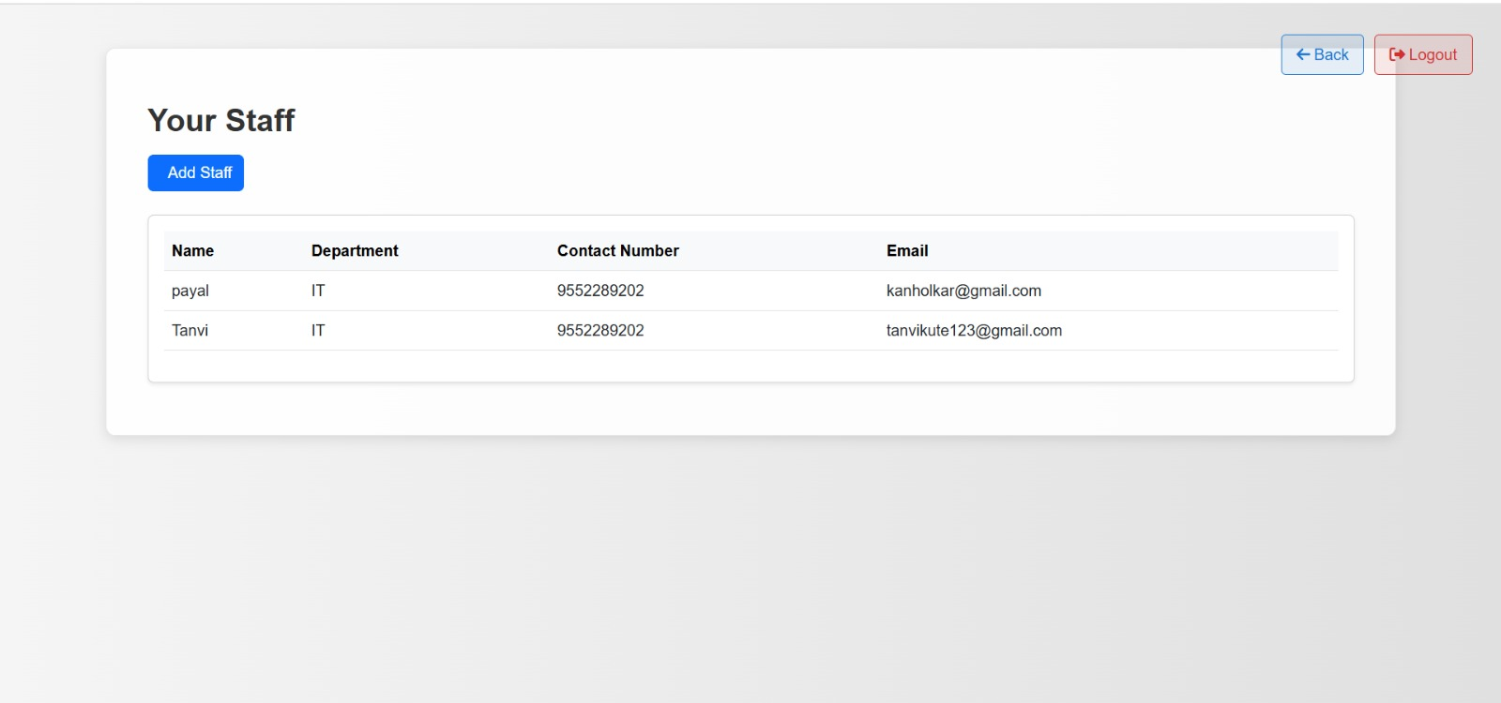**STAFF LIST**

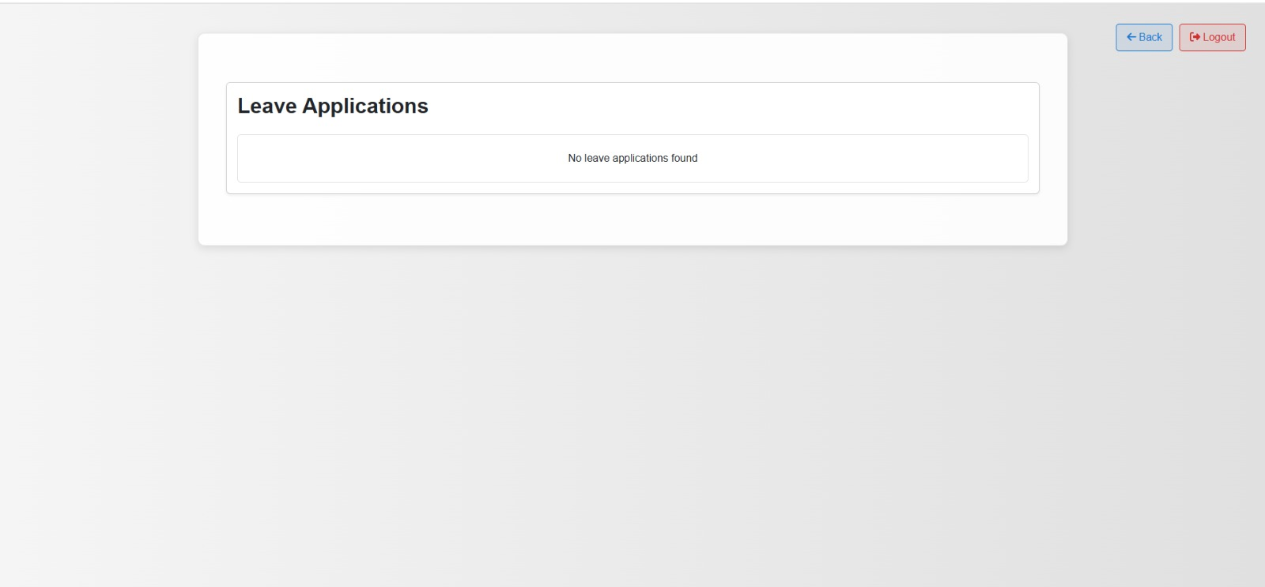**LEAVE REQUESTS**

**UPDATE PROFILE**

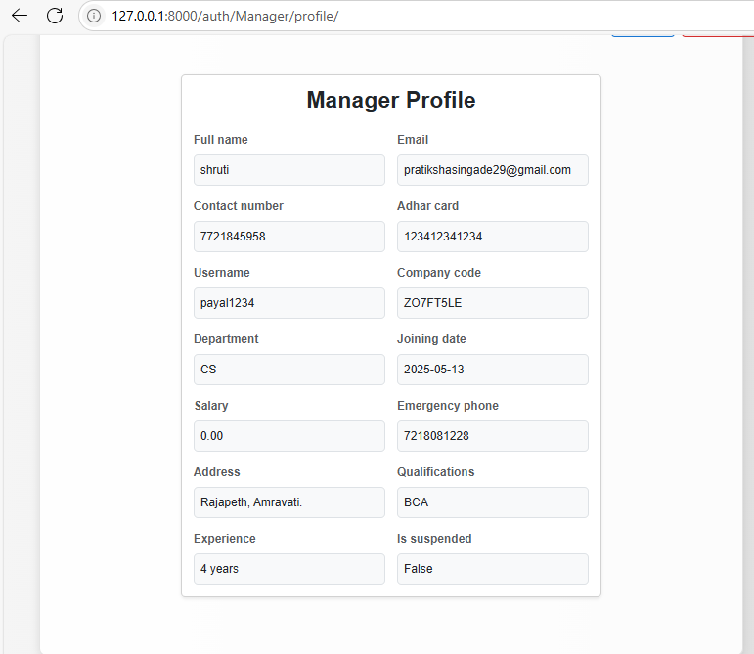

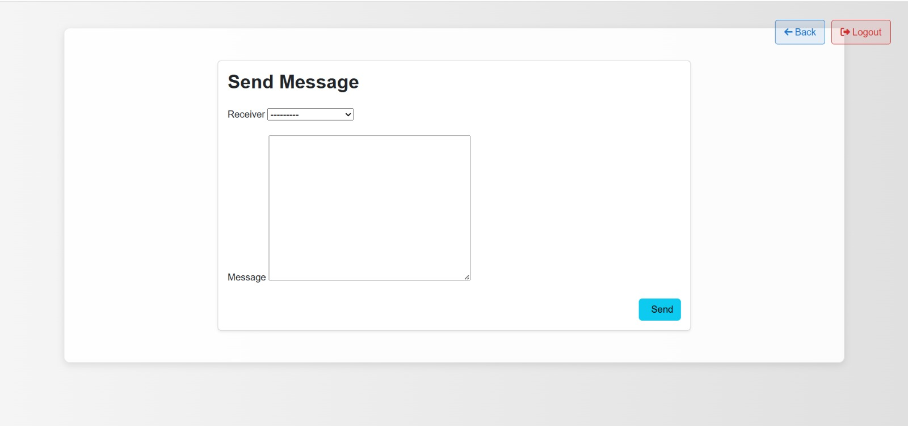**SEND MESSAGE PAGE**

**STAFF APP**

**MAIL SENT AFTER STAFF REGISTRATION**

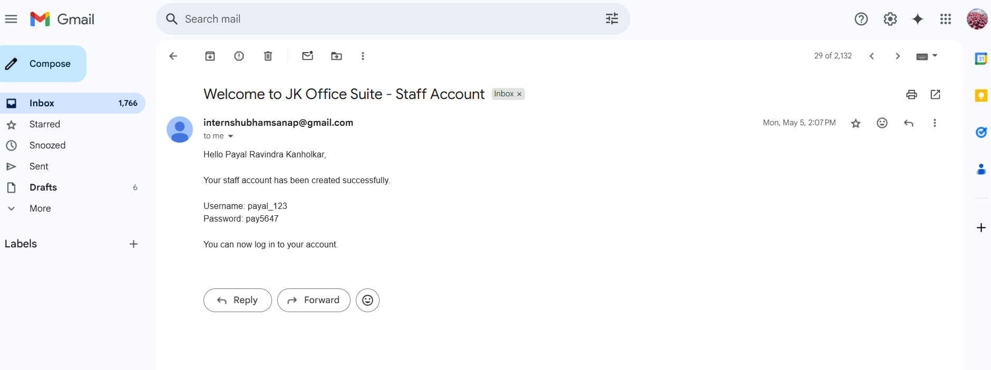

**LOGIN PAGE**

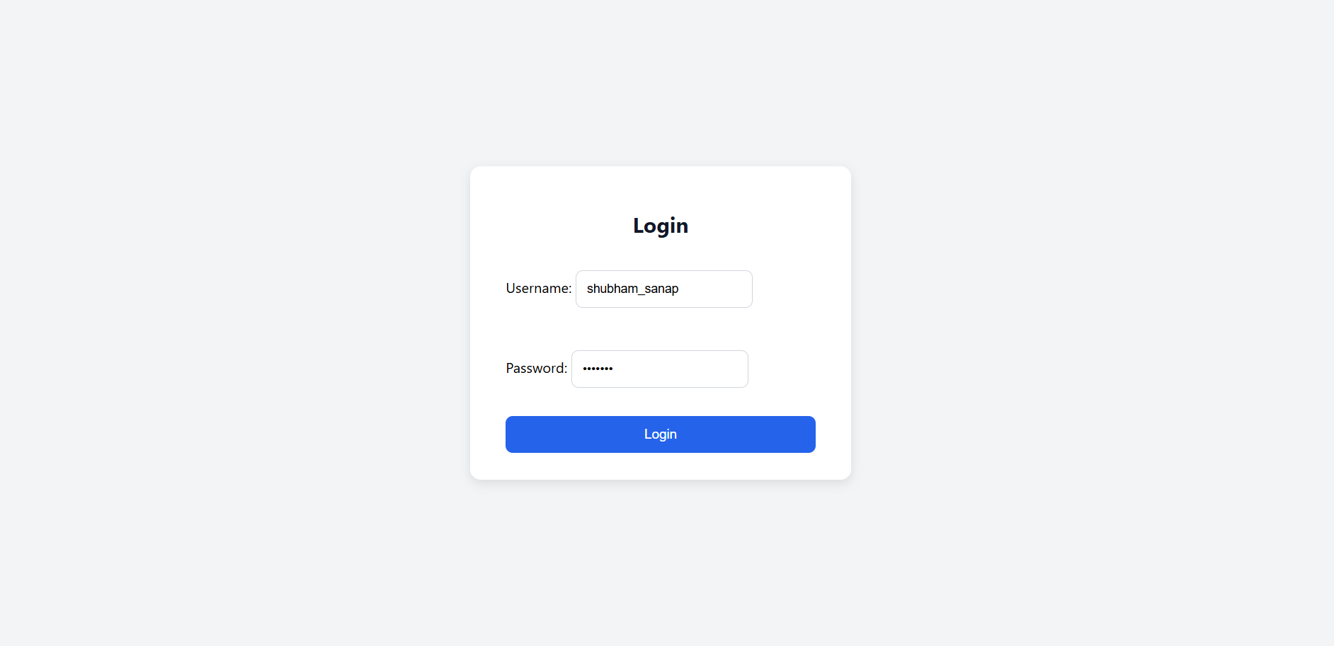

**STAFF DASHBOARD**

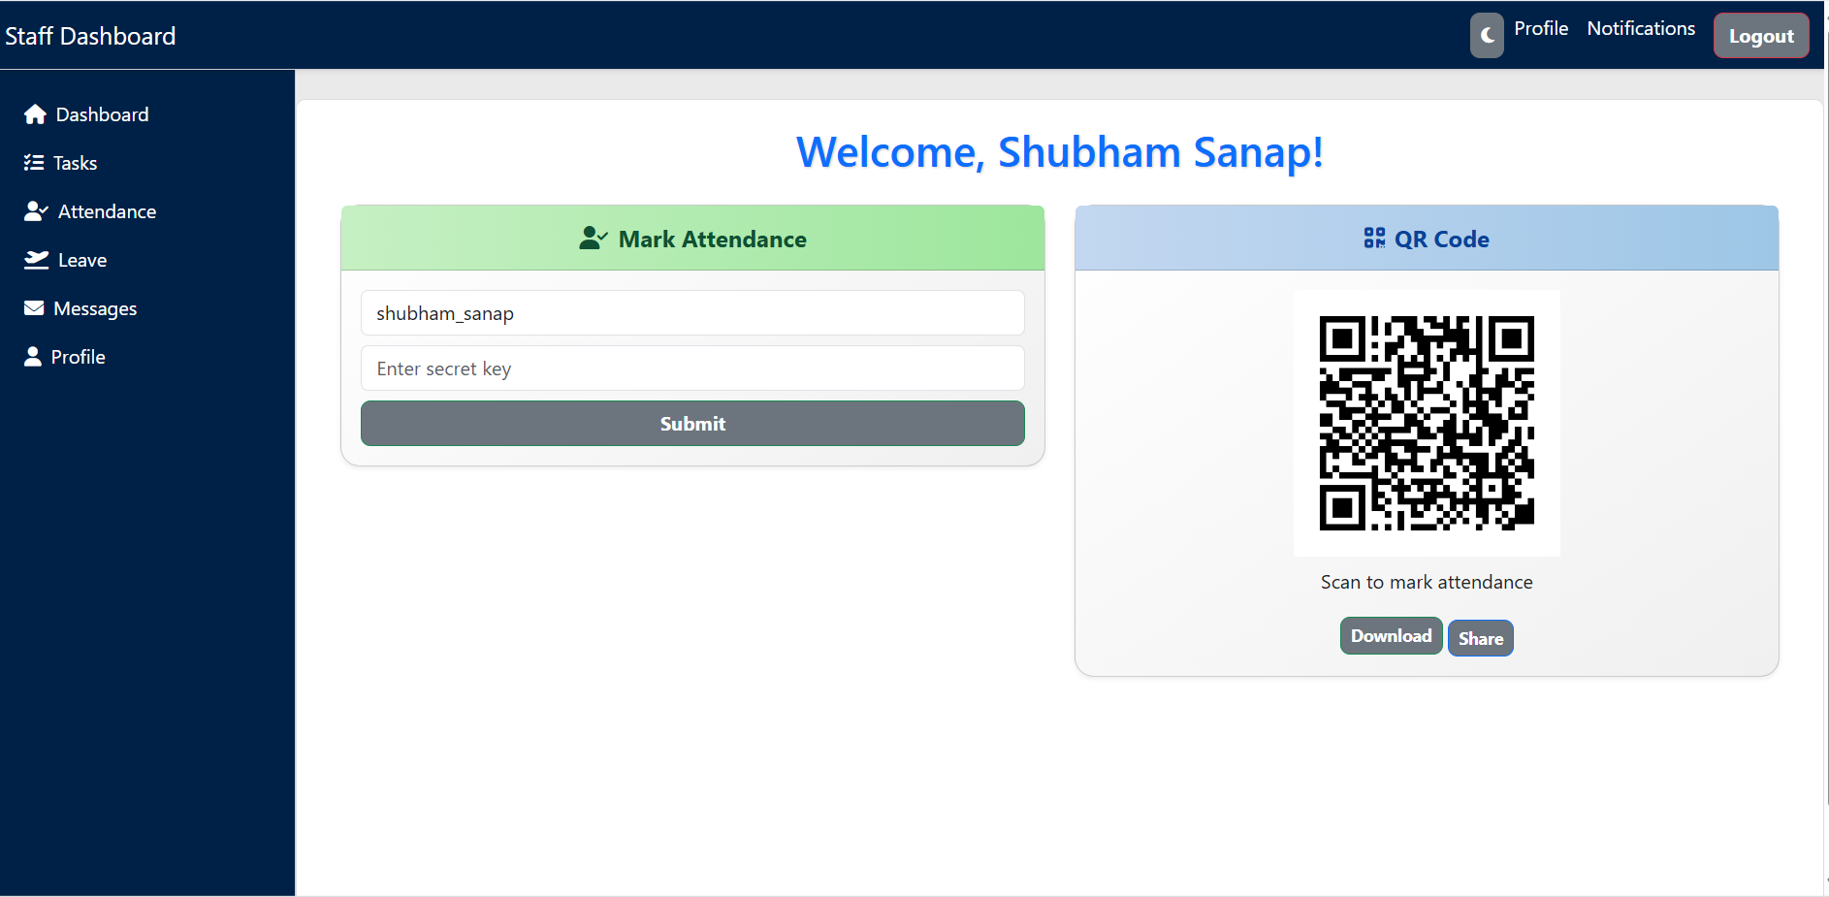

**ATTENDANCE PAGE-I**

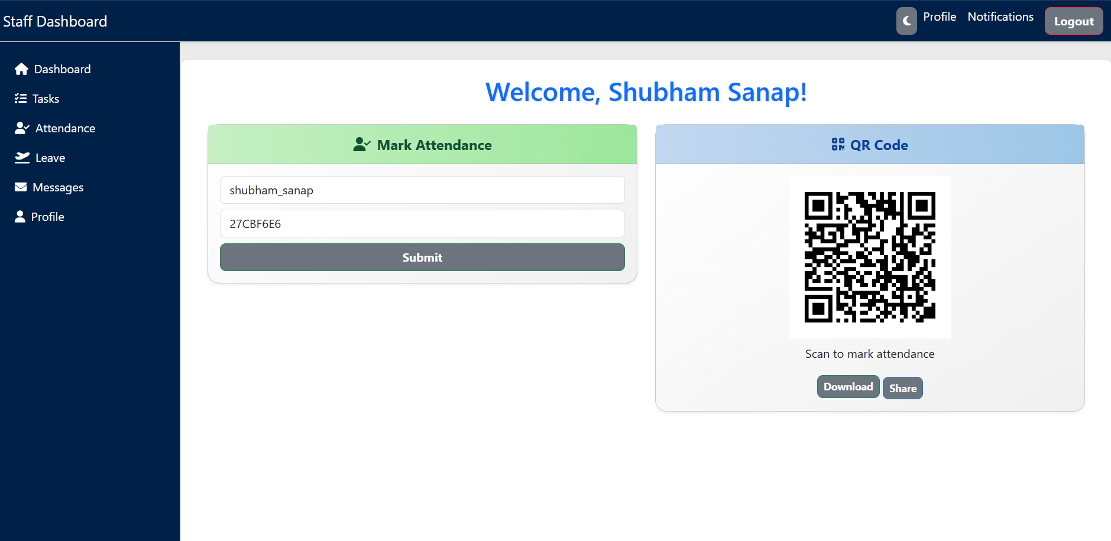

**ATTENDANCE PAGE – II**

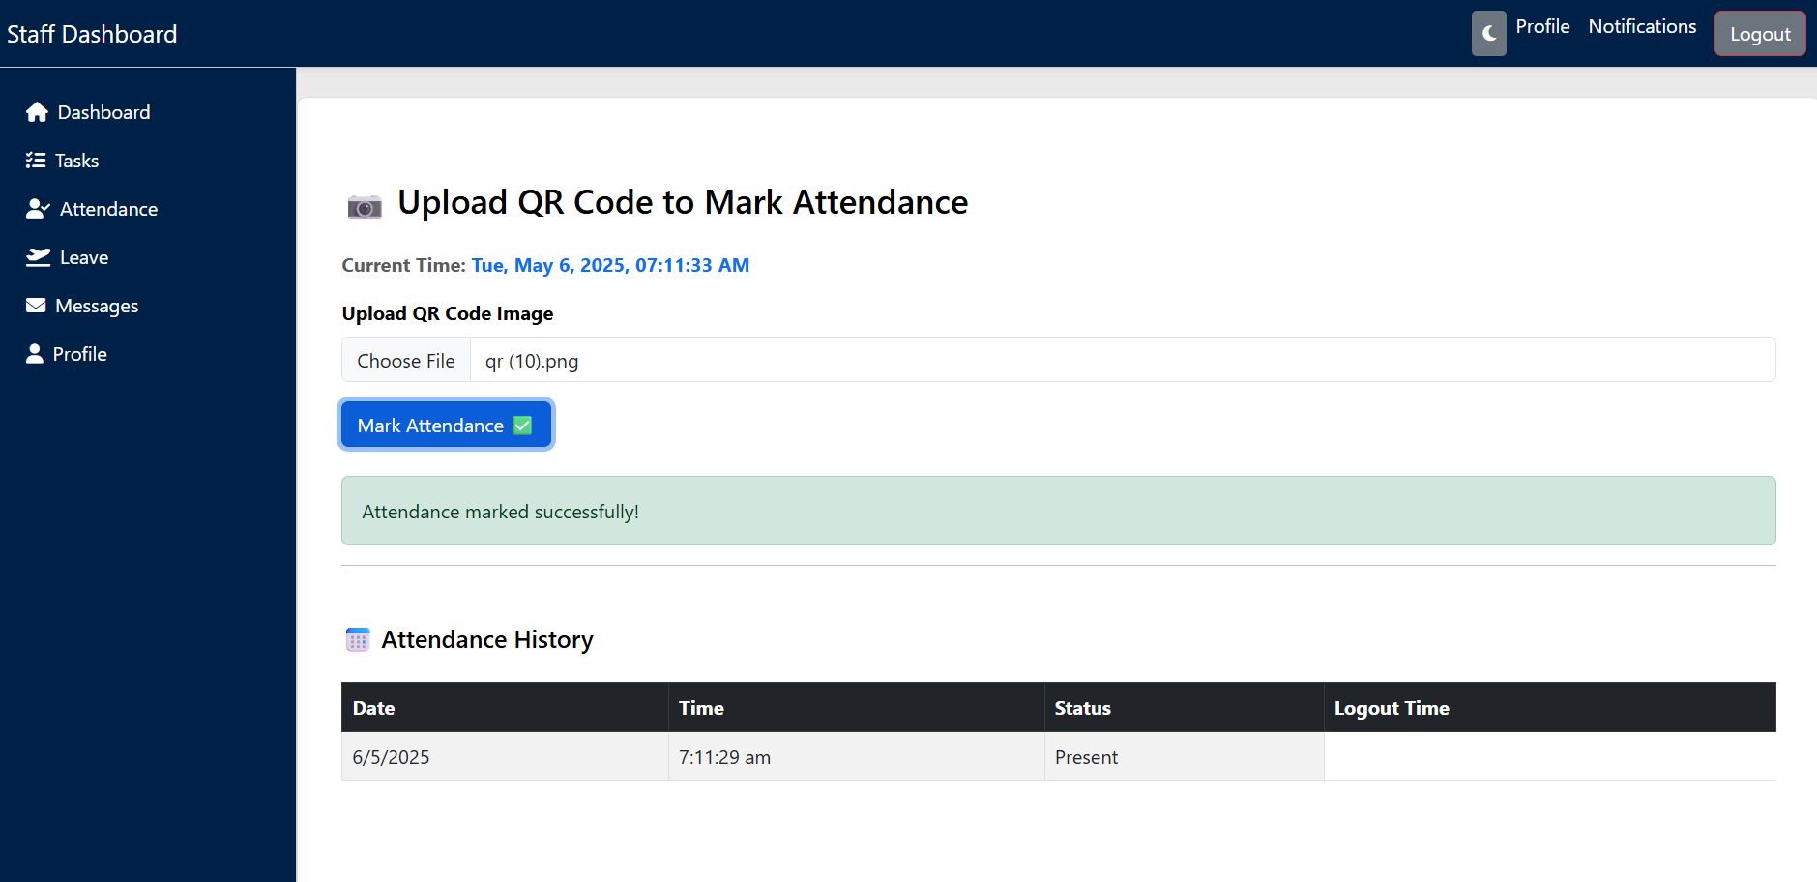

**TASK PAGE – I**

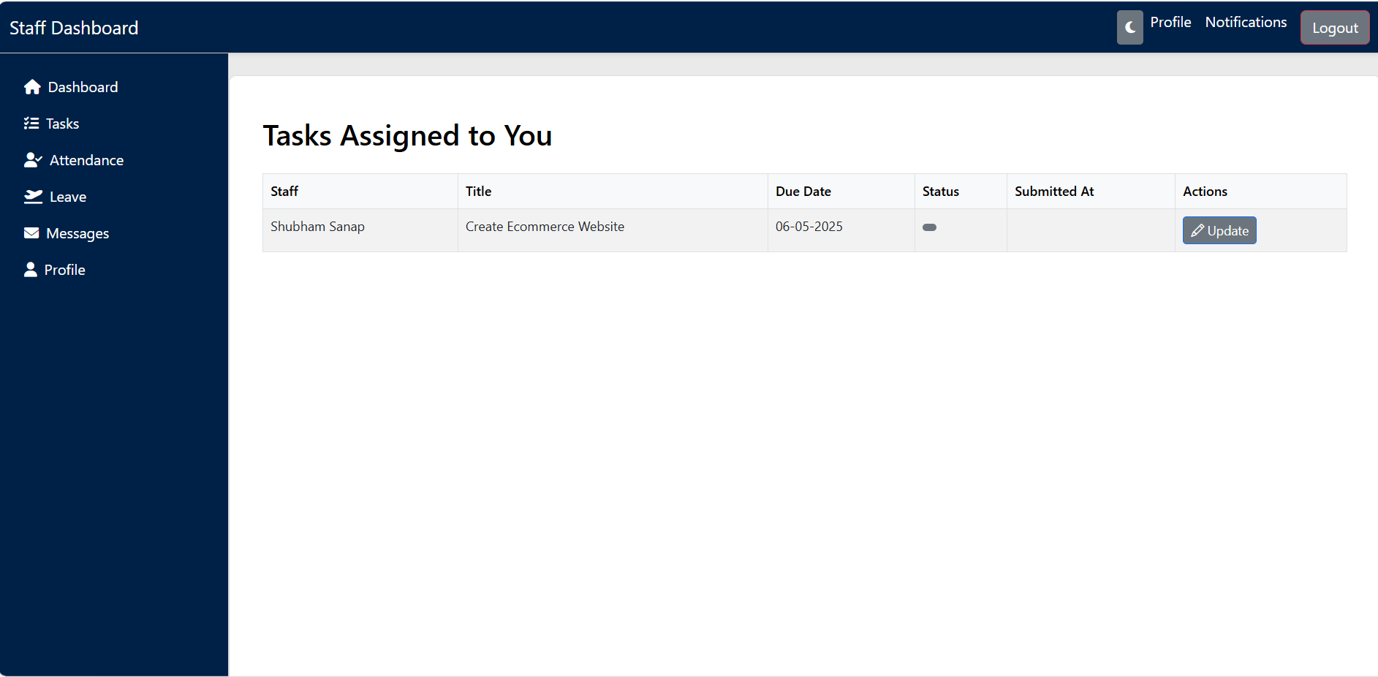

**TASKS PAGE – II**

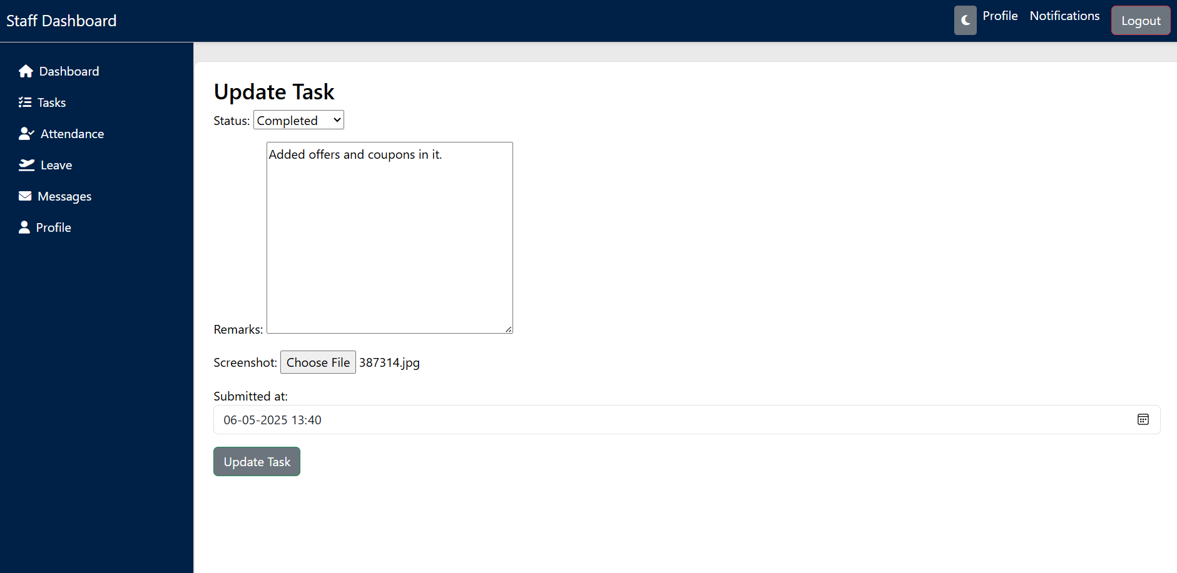

**LEAVE APPLICATION**

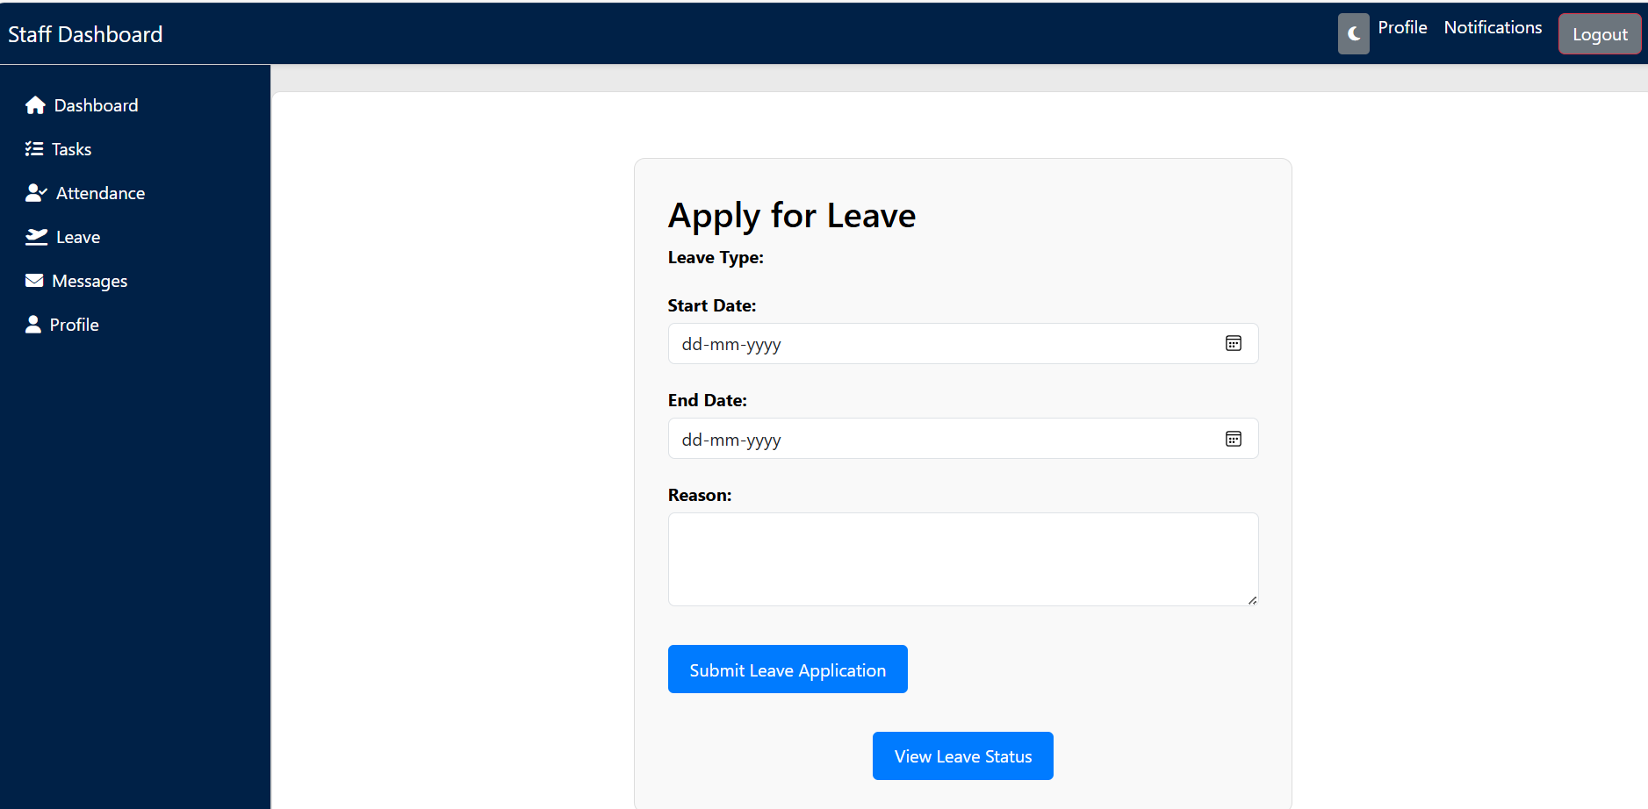

**MESSAGE**

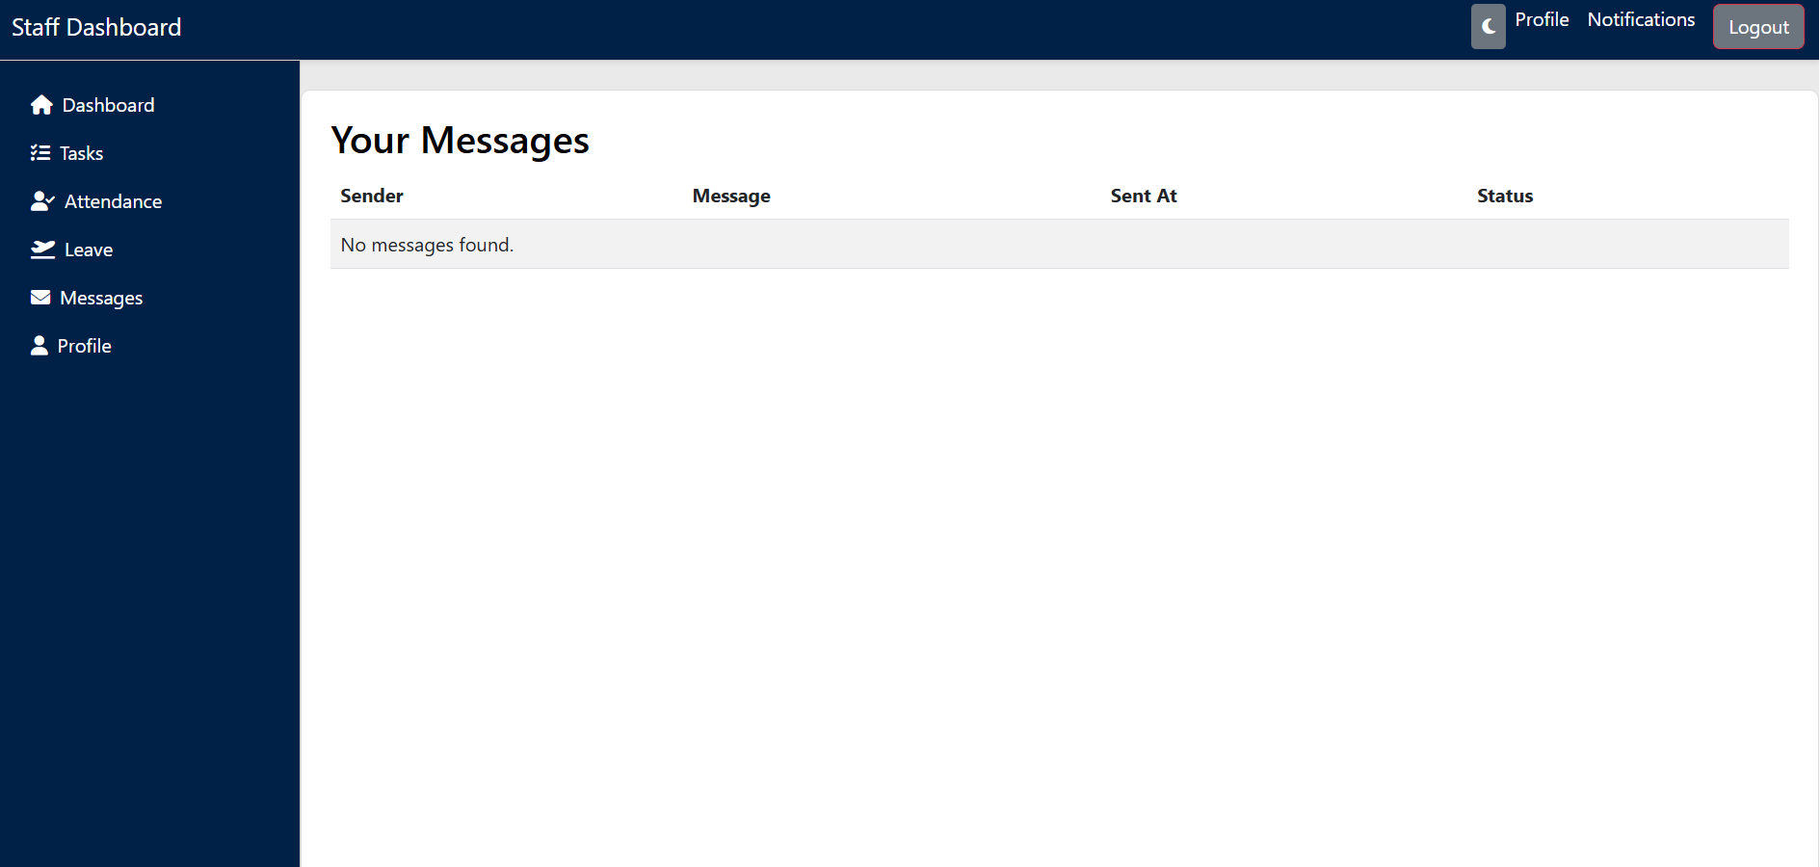

**PROFILE**

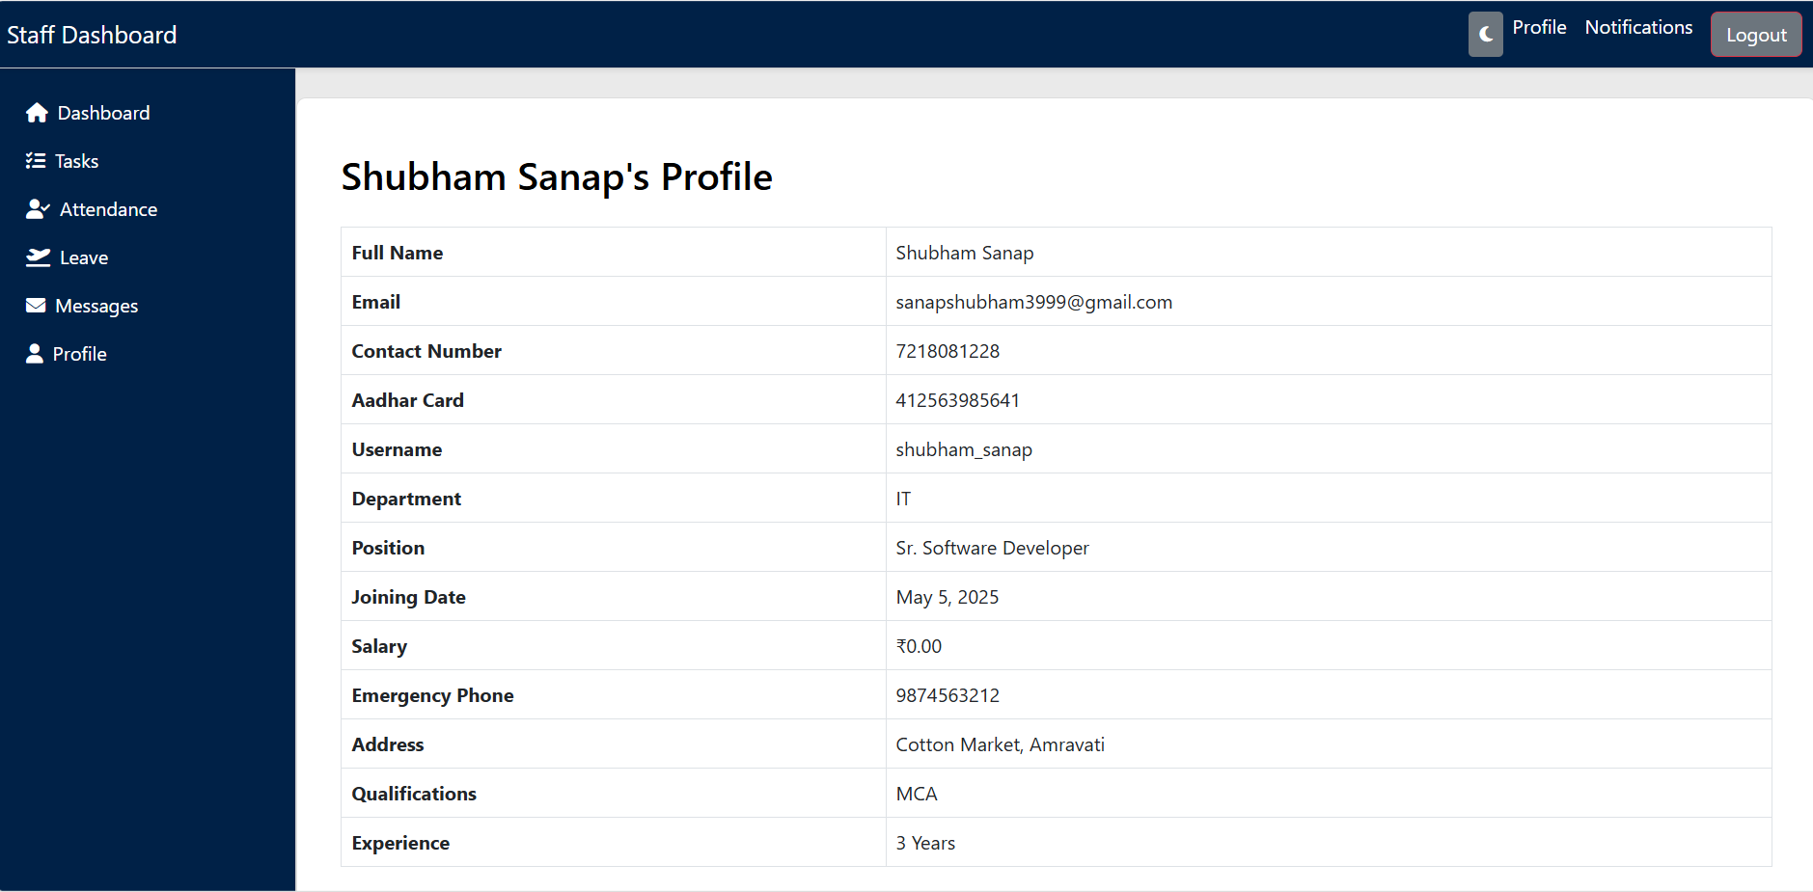

**NOTIFICATIONS**

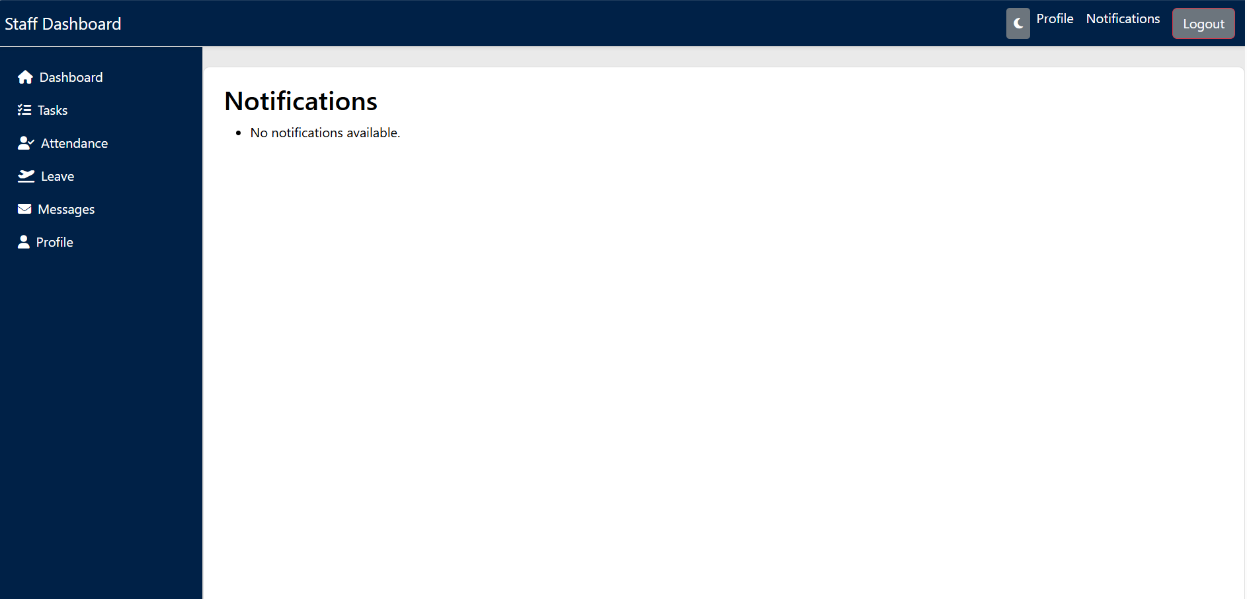

**ADMIN PANEL**

**ADMIN LOGIN PAGE**

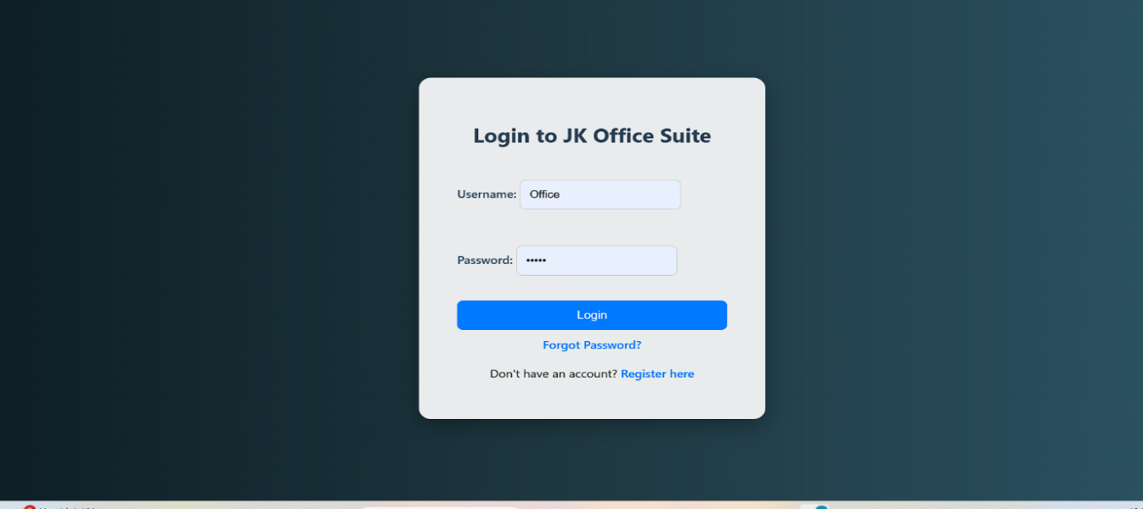

**DATABASE**

**COMPANY DETAILS**

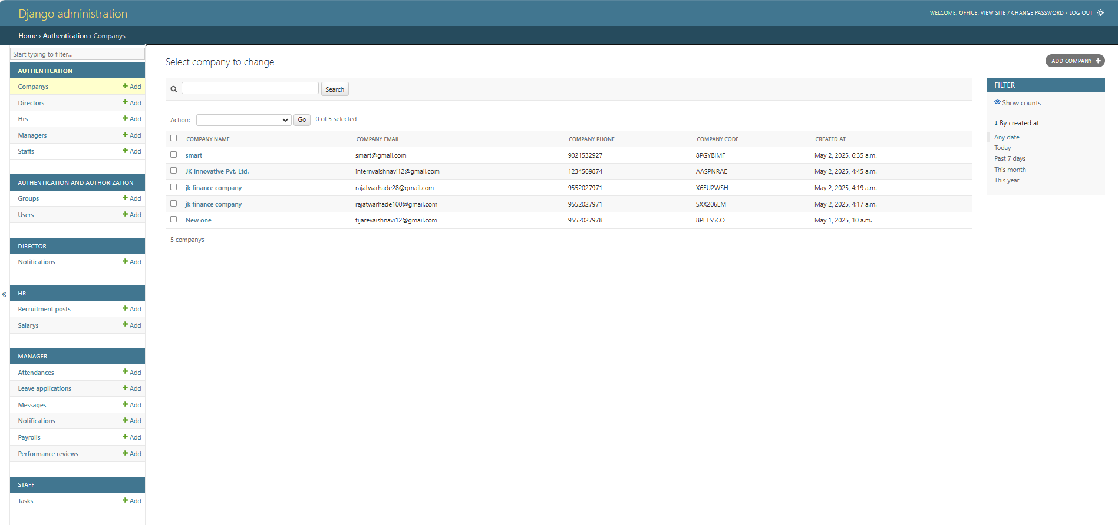

**DIRECTOR DETAILS**

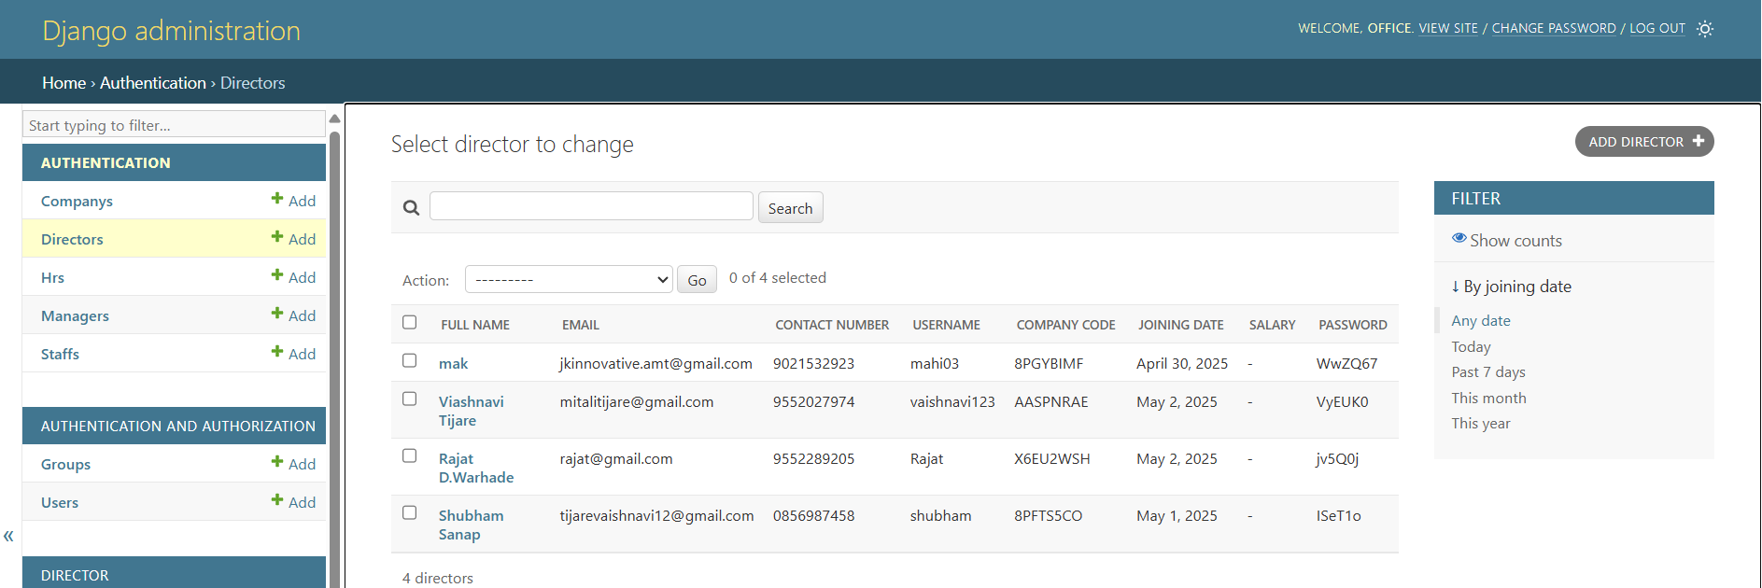

**HR DETAILS**

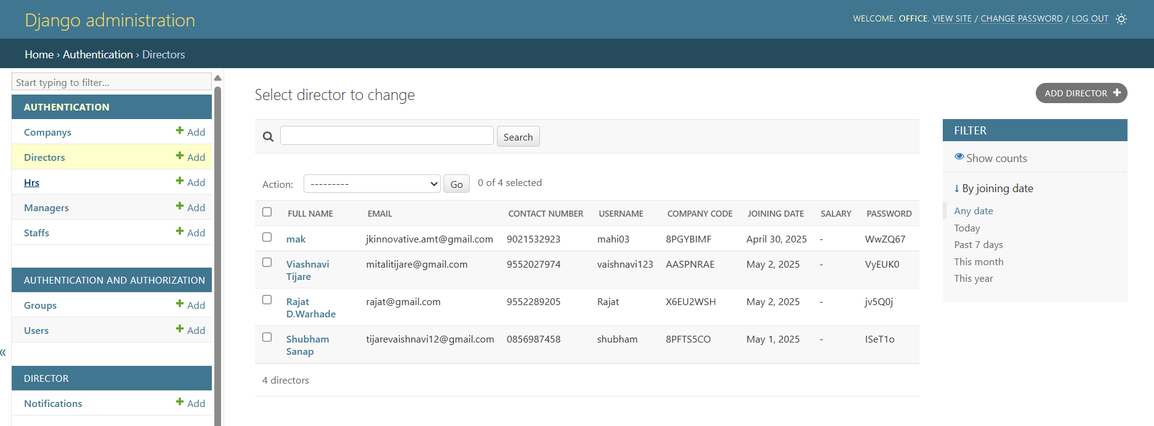

**MANAGER DETAILS**

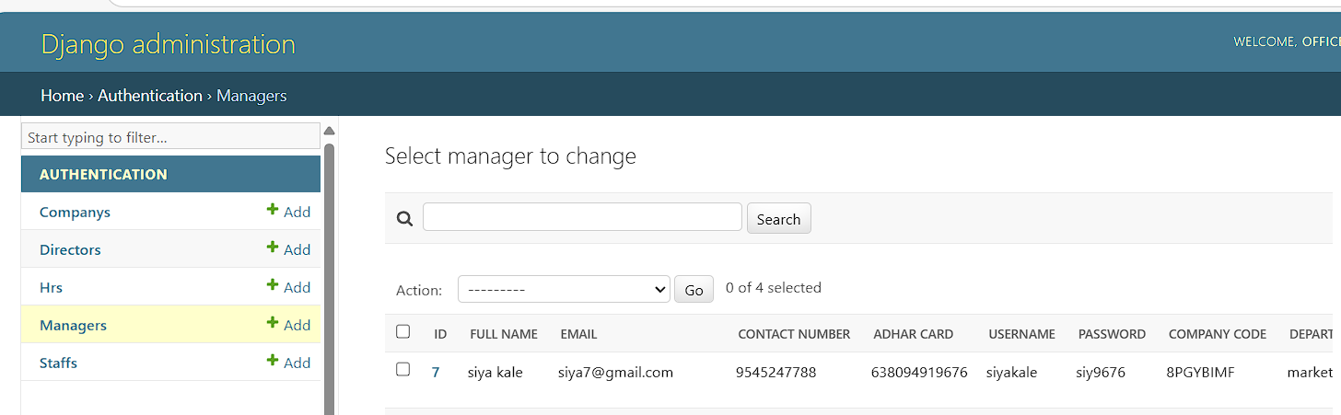

**STAFF DETAILS**

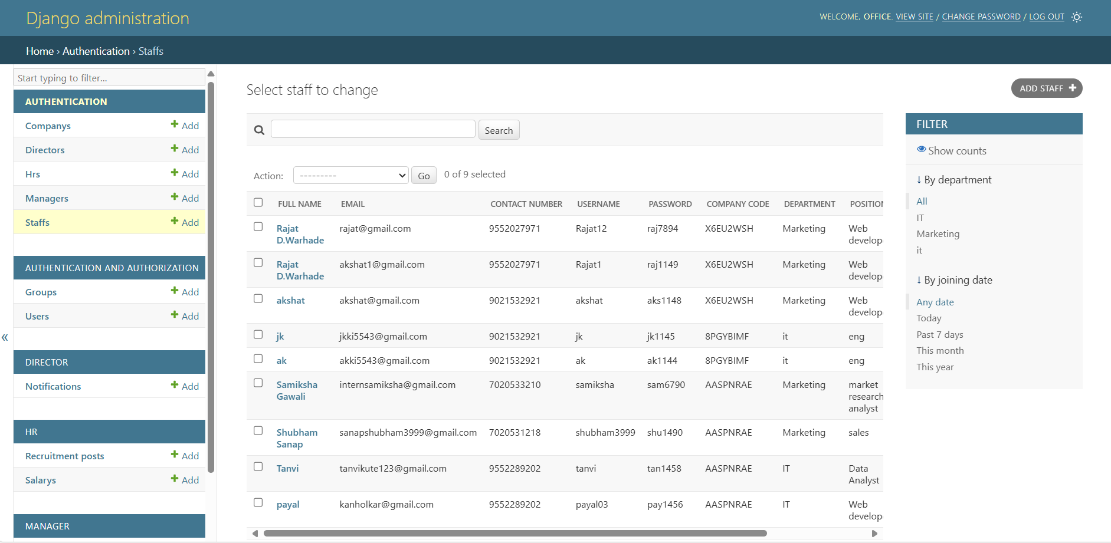

### **8. ADVANTAGES**

The JK Office Suite provides several key benefits to organizations by streamlining internal operations:

#### 1. Centralized Control

All HR, task, leave, and attendance functionalities are combined into one unified platform.

#### 2. Role-Based Access

Custom dashboards and permission-based modules improve security and task clarity for each user type (Director, HR, Manager, Staff).

#### 3. Unique Company Code System

Ensures proper user-company association and prevents unauthorized access during registration.

#### 4. QR Code-Based Attendance

Reduces manual attendance errors and saves administrative time.

#### 5. Task Management & Tracking

Real-time task assignment, progress tracking, and error reporting help ensure transparency and accountability.

#### 6. Notifications & Alerts

Automated email/SMS notifications for task updates, leave status, and important announcements improve communication.

#### 7. Performance Analytics

Directors and HRs can access real-time performance metrics and generate reports to guide decision-making.

#### 8. Scalable and Modular

Easily adaptable for companies of different sizes and customizable for future features like payroll or recruitment.

### **9. DISADVANTAGES**

While the JK Office Suite offers many benefits, it also has some limitations to consider:

**1. Initial Learning Curve**

Users unfamiliar with digital office systems may require basic training to use the platform efficiently.

**2. Dependency on Internet**

As a web-based system, uninterrupted internet connectivity is essential for real-time operations.

**3. Implementation Time**

Setting up the system with all modules and training employees may require initial time investment.

**4. Device Dependency for QR**

Staff need access to smartphones or QR scanners to mark attendance effectively.

**5. Limited Offline Functionality**

The system may not support offline work modes, which can be problematic in low-connectivity areas.

**10. CONCLUSION**

The **JK Office Suite – Enterprise Office Management Portal** is a robust and scalable web-based solution tailored for modern organizations seeking to streamline their internal operations. By integrating modules for employee management, QR-based attendance tracking, task assignment with error reporting, and multi-level leave workflows, the suite addresses key administrative and operational challenges faced by companies.

With clearly defined user roles—Director, HR, Manager, and Staff—the system ensures data security, workflow transparency, and role-specific functionality. Features like real-time notifications, a unique company code system, centralized dashboards, and performance analytics empower organizations to improve productivity and decision-making.

Built using modern web technologies and designed with scalability in mind, the JK Office Suite is suitable for small to large enterprises. It not only automates repetitive tasks but also fosters better communication and accountability among employees, making it a valuable tool for digital transformation in workplace management.

In summary, the JK Office Suite delivers a comprehensive, secure, and efficient digital environment for managing the complete lifecycle of employee-related processes within any organization.

**11. REFERENCES**